Contents

1. What is Bootstrap? And its Advantages.
2. Where to get BootStrap?
3. Simple application.
4. Containers.
5. Grid System.
6. Trypographic elements.

6.1)Inline elements.

6.2)Text Alignment-classes.

6.3)Text Emphasis classes.

6.4)Background-classes.

6.5)Block Quotes.

6.6)Abbreviations.

6.7)Text case Transformation classes.

6.8)List

6.8.1)List Group.

6.9)Table.

7) Forms

7.1)Vertical Layout/Default Layout/Basic Layout.

7.2)Horizantal Layout

7.3)Inline layout.

8) Buttons.

9) Images.

9.1)Image shapes.

10)Helper classes.

10.1)glyphicons.

10.2) closeicon.

10.3)caret.

10.4)center-content-block.

10.5)Pull-left

10.6)pull-right

10.7)show

10.8)hidden.

11. nav

11.1) Nav

11.2)nav-tabs.

11.3)nav-pills.

11.4)diff between nav-tabs and nav-pills

11.5)justified.

11.6)disabled.

11.7)NavBar

11.8)Tabs.

12)BreadCrumb.

13)pagination

14)Badge.

15) Label

16)Progress bar

17)alert

18)Jumbotron

19)card

20)Pager

21)carousel plug-In--------------🡪pending

22)Modal.

23) Affix.

24)Scroll spy-----🡪pending

25)Tooltip.

26)popover

27)spinner.

28) BootStrap-4 Utilities

28.1) Float.

28.2) position

28.3)Border

28.4)sizing.

28.5)spacing.

28.6)shadow.

28.7)display.

28.7.1) flex.

28.8) Nav.

29)How to add internal icons and external icons to html file?

30)How to use google fonts in html file?

31) Difference between the bootstrap3 and bootstrap4.

32)colors.

1.what is BootStrap?

The bootstrap is free (or) open source & CSS frame work. It has been made up with HTML,CSS and JS.

Advantages:-

1. Easy-to-use:- Any body with basic knowledge of html and css can use boot strap.
2. Responsive Design: Through bootstrap you can easily create responsive design. If your website is responsive then it adjusts itself according to the screen size in any platform or device like desktop, laptop, mobile etc.
3. Cross Browser Comptability: Bootstrap is designed in such a way that our web-page will look the same in almost all modern browsers like Firefox, Chrome, Internet Explorer, Opera etc.
4. Customization: Bootstrap is easy to customize, customize means that if you do not want all the features of bootstrap, you can only use a few features. On Bootstrap’s website give you a lot of options (Nav bar, Table, Form, Button, Model, Dropdown, Badges, etc.) Let you tick what you want, remove the tick from what you don’t want and download and use it.

2.Where to get Bootstrap?

There are two ways to start using bootstrap on websites.

1. Downloading bootstrap from getbootstrap.com
2. Include Bootstrap from CDN.CDN(content Delivery Network) is geographically distributed group of servers that work together for providing fast content delivery.

2.a) Downloading Bootstrap:-

Step1: Goto getbootstrap.com website.

Step2: click on download bootstrap button.

The file named bootstrap 3.3.7 dis1.zip. It includes css,fonts,js.

2.b) BootStrap CDN:-

<!—lastest compiled & minified Css->

<link rel=”stylesheet” href=”https://maxcoln.bootstrapcdn.com/bootstrap/3.3.7/css/bootstrap.min.css”.>

<!—jquery library🡪

<script src=<https://ajax.google.apis.com/ajax/libs/jquery/3.3.7/jquery.min.js>>

</script>

<!—Latest minificed & compiled java script🡪

<script src=<https://maxcoln.bootstrapcdn.com/bootstrap/3.3.7/js/bootstrap.min.js>></script>

Note:- Bootstrap uses jquery for java script plugins(like modals,tooltips,etc).How ever, if you just use css part of bootstrap,you don’t need jquery.

Download Popper javascript File

Step1: goto [www.unpkg.com/popper](http://www.unpkg.com/popper)

Step2: Save the popper.js file in desired location of local computer.

3.simple Application:-

3.1)With out bootstrap

<!DOCTYPE html>

<html>

<head>

<meta charset="utf-8">

<title>sample Page</title>

<!--<link rel="stylesheet" type="text/css" href="C:/Users\Personal/Desktop/Bootstrap/css/bootstrap.css">

<script type="text/javascript" src="C:/Users/Personal/Desktop/Bootstrap/js/bootstrap.js"></script>

<script type="text/javascript" src="C:/Users/Personal/Desktop/Bootstrap/jquery-3.5.0.min.js"></script> -->

</head>

<body>

<h1>sukumar</h1>

<p>This is sukumar. hai</p>

</body>

</html>

Output:-

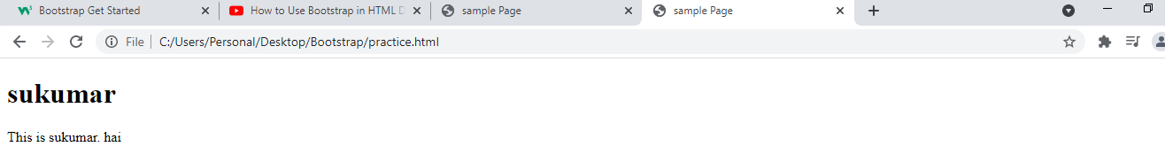

With bootstrap:

<!DOCTYPE html>

<html>

<head>

<meta charset="utf-8">

<title>sample Page</title>

<link rel="stylesheet" type="text/css" href="C:/Users\Personal/Desktop/Bootstrap/css/bootstrap.css">

<script type="text/javascript" src="C:/Users/Personal/Desktop/Bootstrap/js/bootstrap.js"></script>

<script type="text/javascript" src="C:/Users/Personal/Desktop/Bootstrap/jquery-3.5.0.min.js"></script>

</head>

<body>

<h1>sukumar</h1>

<p>This is sukumar. hai</p>

</body>

</html>

Output:

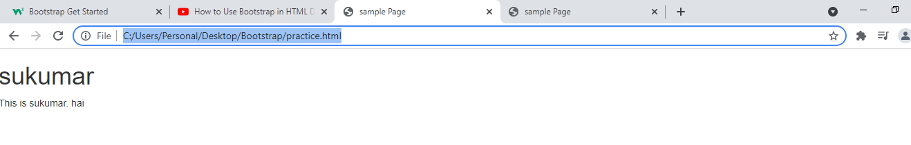

4)Containers:- Bootstrap requires containing element to wrap web content. The web content image,table,heading ,paragraph …other. There are two container classes.

1).container

2).container-fluid.

4.1) .container:- This class provides fixed width container in view port. This container does not occupy entire width of viewport.

There is no top-bottom margins to container.

Example:-

<!DOCTYPE html>

<html>

<head>

<meta charset="utf-8">

<title>sample Page</title>

<link rel="stylesheet" type="text/css" href="C:/Users\Personal/Desktop/Bootstrap/css/bootstrap.css">

<script type="text/javascript" src="C:/Users/Personal/Desktop/Bootstrap/js/bootstrap.js"></script>

<script type="text/javascript" src="C:/Users/Personal/Desktop/Bootstrap/jquery-3.5.0.min.js"></script>

<style type="text/css">

div{background-color: red;}

</style>

</head>

<body>

<div class="container">

<h2>This is sukumar</h2>

<p>hi how are you?</p>

</div>

</body>

</html>

Output:

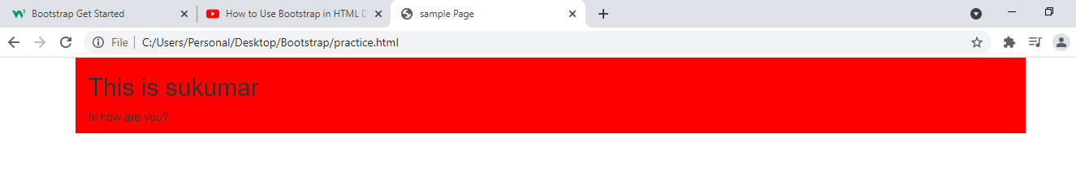

4.2) .container-fluid:- This class provides full width container. This container occupy entire width of view port.

There is no left,top,bottom and bottom margin. There is 4 padding to container.

Example:-

<!DOCTYPE html>

<html>

<head>

<meta charset="utf-8">

<title>sample Page</title>

<link rel="stylesheet" type="text/css" href="C:/Users\Personal/Desktop/Bootstrap/css/bootstrap.css">

<script type="text/javascript" src="C:/Users/Personal/Desktop/Bootstrap/js/bootstrap.js"></script>

<script type="text/javascript" src="C:/Users/Personal/Desktop/Bootstrap/jquery- 3.5.0.min.js"></script>

<style type="text/css">

div{background-color: red;}

</style>

</head>

<body>

<div class="container">

<h2>This is sukumar</h2>

<p>hi how are you?</p>

</div>

</body>

</html>

Output:

----------

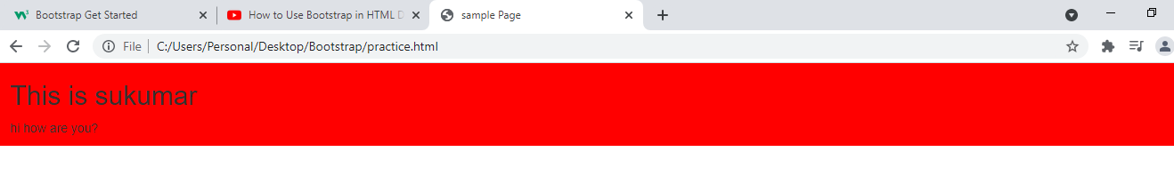

5)Grid System:- Bootstrap includes responsive,mobile first fluid grid system. Grid systems are used for creating page layouts through series of rows and columns.

How Bootstrap grid system works.

1) Rows must be placed within .container (or) container-fluid.

2) use rows to create horizontal group of columns.

3) content should be placed with in column.

4) predefined grid classes like row and .col-xs-*,.col-md-*,.col-sm-*,.col-lg-* are available for making grid layout.

5) columns create gutter (gap between column content) via padding.

6) Bootstrap grid system allows upto 12 equal columns across page width. If you don’t want to use all 12 columns individually. You can group columns together to create wider columns.

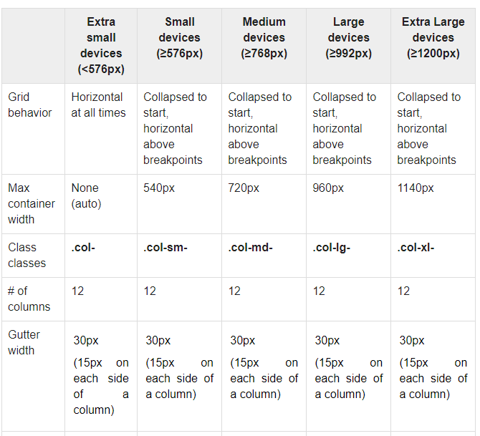

7) The columns can be nested.

5.1) Media queries:- The following media queries are used to create key break points in our grid system.

a) Extra small devices (phone,<768px)

No media query for extra small devices. This is default in bootstrap.

b)For small devices (tables,>768px &&<=991px)

@media(min-width:@screen-sm-min) and (max-width:@screen-sm-max){--------}

c)For Medium devices(desktop,>=992px and <=1199px)

@media(min-width:@screen-md-min) and (max-width:@screen-md-max){--------}

d)For large Devices(large desktops, >=1200px)

@media (min-width:@screen-lg-min)

Note:- we also pass resolution as argument to min-width and max-width property .

5.2) Grid options:-

Picture

Examples:-1 In this example, one row has 3 different size columns on large system .

<body>

<div class="container">

<div class="row">

<div id="one" class="col-lg-4 "> this is sukumar</div>

<div id="two" class="col-lg-6 "> this is sukumar</div>

<div id="three" class="col-lg-2 "> this is sukumar</div>

</div>

</div>

</body>

Output:

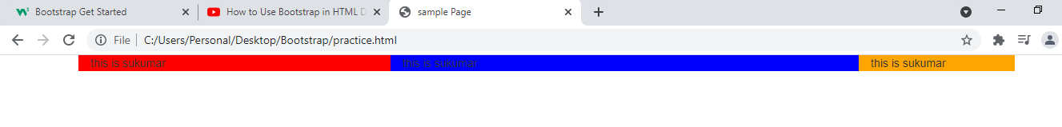

Example:2 In this example, one row has 3 different size columns on large,medium,small,xtra small devices.

<body>

<div class="container">

<div class="row">

<div id="one" class="col-lg-4 col-md-4 col-sm-3 col-xs-2"> this is sukumar</div>

<div id="two" class="col-lg-6 col-md-4 col-sm-3 col-xs-2"> this is sukumar</div>

<div id="three" class="col-lg-2 col-md-4 col-sm-3 col-xs-2"> this is sukumar</div>

</div>

<!--<div class="row">

<div id="two" class="col-xs-4 col-sm-6 col-md-7 col-lg-12"> this is sukumar</div>

</div> -->

</div>

</body>

Output: on large systems.

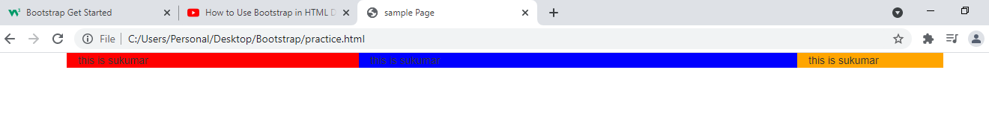

On medium devices.

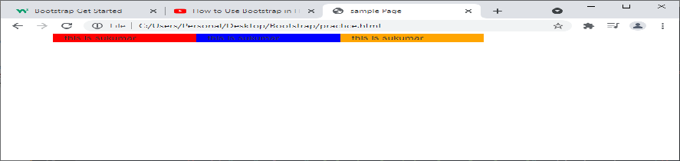

Example3:-In this example, container has two rows and each rows contains different size columns.

<body>

<div class="container">

<div class="row">

<div id="one" class="col-lg-4 col-md-4 col-sm-3 col-xs-2"> this is sukumar</div>

<div id="two" class="col-lg-6 col-md-4 col-sm-3 col-xs-2"> this is sukumar</div>

<div id="three" class="col-lg-2 col-md-4 col-sm-3 col-xs-2"> this is sukumar</div>

</div>

<div class="row">

<div id="two" class="col-xs-4 col-sm-6 col-md-7 col-lg-12"> this is sukumar</div>

</div>

</div>

</body>

Output:

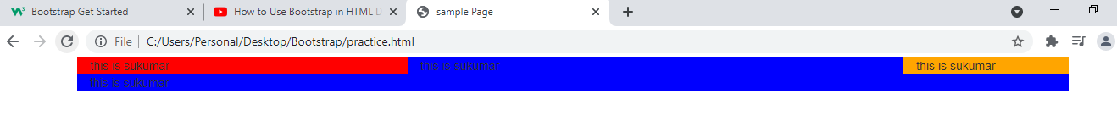

5.3)Column wrapping:- If more than 12 columns are placed with in single row, column group which has extra columns will,as one unit, wrap onto another newline.

Examples:-

<body>

<div class="container">

<div class="row">

<div id="one" class="col-lg-4 "> this is sukumar</div>

<div id="two" class="col-lg-5 "> this is sukumar</div>

<div id="three" class="col-lg-4 "> this is sukumar</div>

</div>

</div>

</body>

Output:-

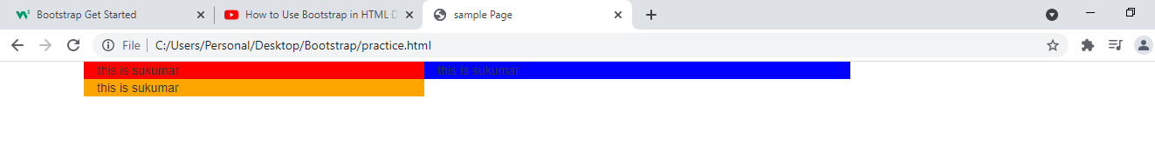

5.4) offsetting columns:- Move columns to right using col-md-offset-*,col-xs-offset-*,col-sm-offset-* and col-lg-offset-* according device type.

Examples:-

<body>

<div class="container">

<div class="row">

<div id="one" class="col-lg-3 col-lg-offset-3"> this is sukumar</div>

<div id="two" class="col-lg-3 "> this is sukumar</div>

<div id="three" class="col-lg-3 "> this is sukumar</div>

</div>

</div>

</body>

Output:-

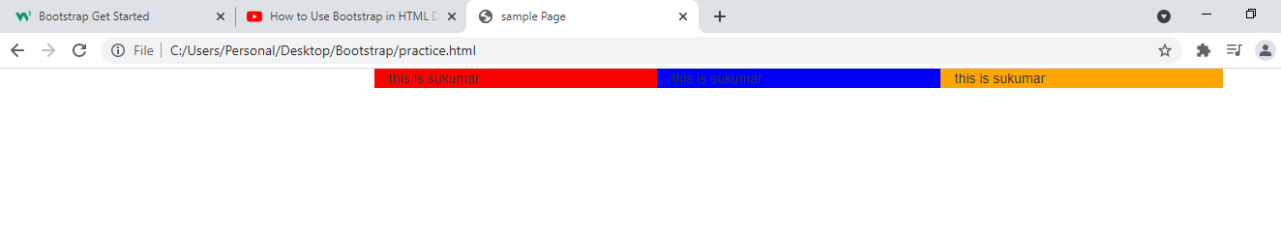

5.5) Reordering columns:- At times ,you want to display columns in different order on screen. Bootstrap provides the col-push-*-* and col-pull-*-* classes for this. While col-push-*-* will move column to right by * units and col-pull-*-* moves column to left by * units.

Device Reorder-class Names

----------- --------------------------

Xs col-push-xs-*,col-pull-xs-*;

Md col-push-md-*,col-pull-md-*;

Sm col-push-sm-*, col-pull-sm-*;

Lg col-push-lg-*,col-pull-lg-*;

Examples:-1 The first columngroup moved 6 columns to right. It will be behind the remaining columngroups. There it will not appear.

<body>

<div class="container">

<div class="row">

<div id="one" class="col-lg-3 col-lg-push-6"> this is sukumar</div>

<div id="two" class="col-lg-3 "> this is sukumar</div>

<div id="three" class="col-lg-3 "> this is sukumar</div>

</div>

</div>

</body>

Output:

----------

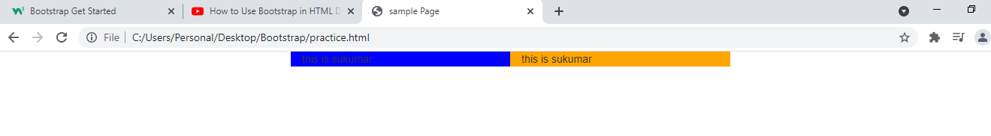

Example:2 The first column group moved 7 column to right. It will appear partially . Rest of part will be hidden behind the 2 column groups.

<body>

<div class="container">

<div class="row">

<div id="one" class="col-lg-3 col-lg-push-8"> this is sukumar</div>

<div id="two" class="col-lg-3 "> this is sukumar</div>

<div id="three" class="col-lg-3 "> this is sukumar</div>

</div>

</div>

</body>

Output:

----------

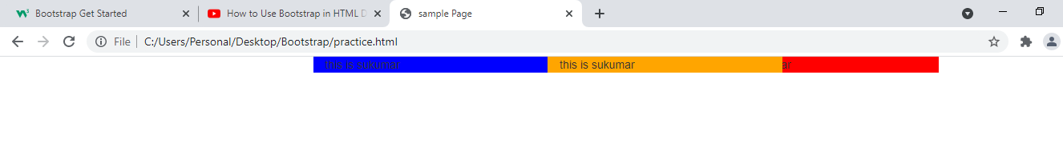

6.Trypographic Elements:- Trypographic is feature of bootstrap for styling and formatting the text. Bootstrap provides consistent styling across browsers for common trypographic elements . These elements are inline elements,alignments ,emphasis classes,abbreviations,addresses,blockquotes and lists.

6.1)Inline Elements:-

6.2) alignment-classes:-Bootstrap has 4 classs to align text to left,right,and center of its parent block element. The four classes are

a)text-start

b)text-end

c)text-center

d)text-justify.

6.3) Emphasis classes:- Bootstrap provides css classes that changes color of text to indicate special meaning.

a)text-primary:- (sky blue shade) It is used to indicate text that is relevant based on priority.

b)text-info:- (blue shade) It can be used to indicate general information.

c)text-danger:- (Red shade) It can be used to indicate dangerous action,errors,..etc.

d)text-success:- (green shade) It can be used to indicate success after action.

Ex:- such as form submission.

e) Text-warging:- (orange shade) It can beused to indicate warning that is going to create problem.

f)Text-muted:- (light gray) it can be used to dimish importance of text.

6.4) Background-classes:- Bootstrap provides css classes that changes background color of element.

a)bg-primary

b)bg-success

c)bg-warning

d)bg-info

e)bg-danger.

6.5) BlockQuotes:- Blockquots are used to indicate enclosed text that originates from another source. The text are displayed by placing <p>element between blockquote element.

Bootstrap adds large border of 5 pixels to left of block quotes. The color of border is light gray.

6.6)Abbreviations:- Abbrevations should be displayed using <abbr> element width title attribute. Bootstrap adds light gray,dotted line at bottom of <abbr>element.

Ex:-<abbr title=”hypertext markup language’> html</abbr>

Bootstrap provides initialism css class, which transform<abbr>content to uppercase.

Ex:-<abbr title=”Hypertext marup language” class=”Initialism”>html</abbr>

Output:- HTML

Note:- if<abbr> does not has title attribute (or) initialism class, bootstrap does not apply any style to content of <abbr>.

6.7) Text case Transformation classes:-

a) text-uppercase

b)text-lowercase

c)text-capitalize.

6.8) Text decoration Classes:-

1. Text-decoration-underline.
2. Text-decoration-line-through

6.9) Font Related Classes:-

1. Font-Size Related classes:-

i.fs-1

ii.fs-2

iii.fs-3

iv.fs-4

v.fs-5

vi.fs-6

1. Font-Style Related Classes:-

i.fst-italic

ii.fst-normal.

1. Font-weight Related Classes:-

i.fw-bold

ii.fw-bolder

iii.fw-normal

iv.fw-light

v.fw-lighter.

Example:-

<body>

<div class="container ">

<div class="row bg-danger">

<div class="col-lg-10 text-left text-uppercase text-primary"> left justified</div>

</div>

<div class="row bg-success">

<div class="col-lg-10 text-right text-capitalize text-danger">Right justified</div>

</div>

<div class="row bg-warning">

<div class="col-lg-10 text-center text-success"> center</div>

</div>

<div class="row bg-primary">

<div class="col-lg-10 text-center text-success"><abbr title="hyper text mark up language" class="initialism">html</abbr></div>

</div>

</div>

<blockquote><p>Hai this is <cite title="www.w3school.com">sukumar.</cite></p></blockquote>

<p class="mark">Web Technologies</p>

<u>sukumar</u>

<mark>This is sukumar</mark>

<del>Rock</del>

<u>hai h r u?</u>

</body>

Output:

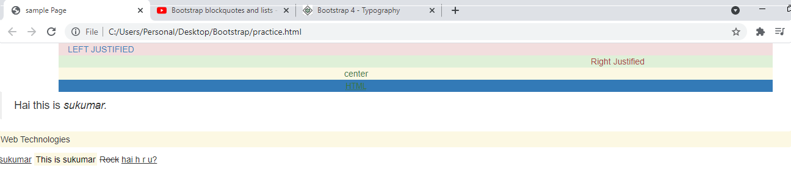

6.10) Lists:- The Boostrap applies styles to orderlist,unorderlist and description list.

Bootstrap provides class to remove default bootstrap styles to list. That class name is list-unstyled. This class removes the left margin of list and it can only be afftected to immediate childrens of list.

Example:-

<body>

<ol class="list-unstyled" >

<li>A.sukumar</li>

<li>A.veena</li>

<li>A.samrajyam</li>

</ol>

</body>

Output:-

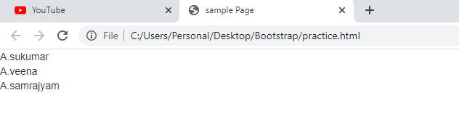

Bootstrap provides another class to apply to bootstrap styles to list . That class name is list-styled.It is default value.

Example:-

<body>

<ol class="list-styled" >

<li>A.sukumar</li>

<li>A.veena</li>

<li>A.samrajyam</li>

</ol>

</body>

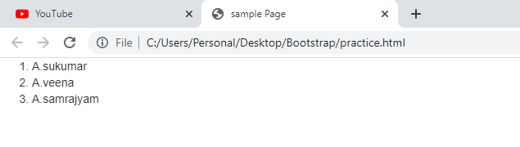

6.10..1) List Group:-

a) Basic list group:- we use <ul>element with .list-group class and <li> with .list-group-item to create basic list group.

b)disable list item:- add .disable class to list item for disabling list item. The disable list item is unclickable with light gray background color.

c)Active list Item:- the .active class highlights list item inlist-group with blue back-background color.

d)contextual classes:- The following contextual clases are used to color the list items. The contextual classes are

a)list-group-item-success

b)list-group-item-info

c) list-group-item-warning

d) list-group-item-danger.

Example:1

<body>

<ol class="list-group" >

<li class="list-group-item">A.sukumar</li>

<li class="list-group-item">A.veena</li>

<li class="list-group-item"> A.samrajyam</li>

<li class="list-group-item">A.sulakshmi</li>

</ol>

</body>

Output:

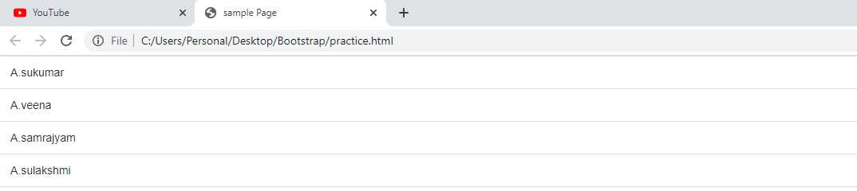

Example:-2

<body>

<ol class="list-group" >

<li class="list-group-item disable">A.sukumar</li>

<li class="list-group-item active">A.veena</li>

<li class="list-group-item list-group-item-success">A.samrajyam</li>

<li class="list-group-item list-group-item-danger">A.sulakshmi</li>

</ol>

</body>

Output:

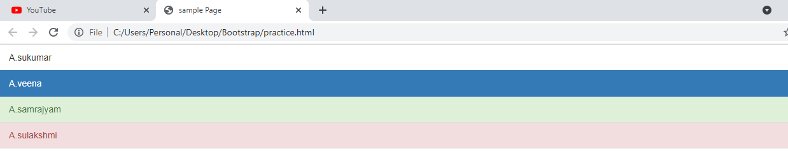

e) custom content:-

a) .list-group-item-heading:- This class created heading for list item in list-group.

b) .list-group-item-text:- This class creates list group item text.

Note:- we can make group with any HTML element using list-group class.

Example:-

<body>

<ol class="list-group" >

<li class="list-group-item "><h3 class="list-group-item-heading">Vegetables</h3>

<p class="list-group-item-text">tomota</p>

<p class="list-group-item-text">Green leaves</p></li>

<li class="list-group-item"><h3 class="list-group-item-heading">Fruits</h3>

<p class="list-group-item-text">Mango</p>

<p class="list-group-item-text">Banana</p></li>

</ol>

</body>

Output

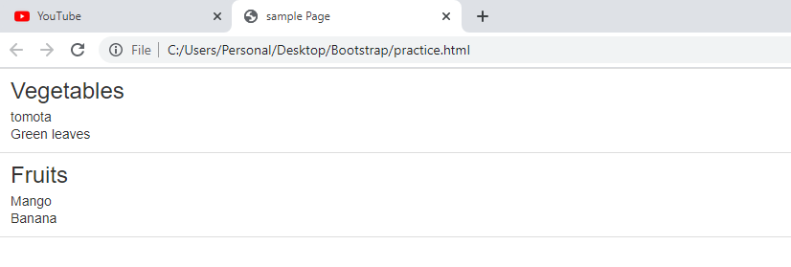

* + 1. List-inline:- Remove a list’s bullets and apply some light margin with a combination of two classes, .list-inline and .list-inline-item.

<ol class="list-inline ">

   <li class="list-inline-item">one</li>

 <li  class="list-inline-item">two</li>

   <li  class="list-inline-item">three</li>

</ol>

6.11) Tables:- To apply basic styles provided by bootstrap, you need to add table css class to HTML table tag in your code.The basic styles which is provided by bootstrap are light padding and only horizontal divider. Use only .table class.

a)Table Bordered:- To add borders on all sides of table and cell , we need to add table-bordered class to HTML tag in your code.

b)Striped rows:- The **table-striped** class adds zebra-striping (or) light gray color background to alternative rows in table.

Note:- Bootstrap does not show differentiate table heading rows and table data rows to add zebra-striping. So if we want to add zebra-stripping to only table data rows, we should put table heading rows in<thead>elements and put table data rows in <tbody>elements.

Example:-

c)border-less:- The table-bordered less class remove borders to table.

Example:-

d)Hover rows:- we add **table-hover** class to <table>element. When we put cursor on any row, that row is highlighted with light gray color background.

e) contextual classes:- use contextual classes to color rows and cells in table. The contextual classes are

a)active

b)danger

c)success

d)warning

e)info.

f) Responsive Table:- create responsive tables by wrapping table in table-responsive tomake then scroll horizontally on small devices 9under 768px). When viesing on any device larger than 768px, you will not see any difference in table.

Example:-1

<body>

<table class="table">

<tr class="active">

<th>Sno</th>

<th>Sname</th>

</tr>

<tr class="danger">

<td>1</td>

<td>sukumar</td>

</tr>

<tr class="success">

<td>2</td>

<td>samrajyam</td>

</tr>

<tr class="warning">

<td>3</td>

<td>veena</td>

</tr>

<tr>

<td>4</td>

<td>sulamaha</td>

</tr>

</table>

</body>

Output:-

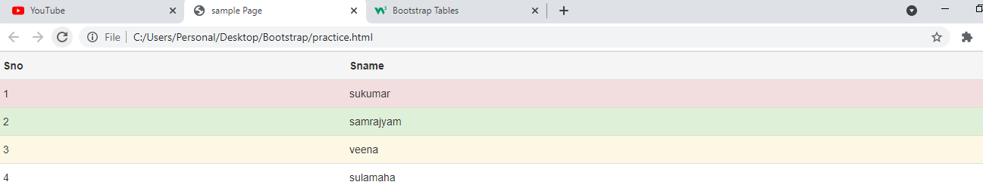

Example:2

<body>

<table class="table-bordered ">

<tr class="active">

<th>Sno</th>

<th>Sname</th>

</tr>

<tr class="danger">

<td>1</td>

<td>sukumar</td>

</tr>

<tr class="success">

<td>2</td>

<td>samrajyam</td>

</tr>

<tr class="warning">

<td>3</td>

<td>veena</td>

</tr>

<tr>

<td>4</td>

<td>sulamaha</td>

</tr>

</table>

</body>

Output:

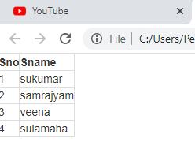

7) Form:- Bootstrap provides 3 form layouts.

a) Vertical layout.

b) Horizantal layout.

c) Inline layout.

7.1) Default Layout:- The form elements automatically gets styleing from bootstrap. To create basic form do following:-

a) Add role=”form” to <form>element.

b)Wrap lable and controls in <div> with class=”form-group”. This need for optimum spacing.

c) Add class of form-control to all textual <input><texare> and <select> elements. The .form-control class allocates full width of browser window to input elements.

7.2) Inline forms:- To display inline form, you need to add for-inline class to form element.

The labels and its associated input element[s] are located in single row side by side.

The form-inline applies to forms within view ports that are at least 768px wide.

7.3) Horizantal form:- To display horizontal form

7.3.1) we should add form-horizantal class to <form> element.

7. 3.2) wrap label and form elements in<div> element and apply class <form-group> .

7. 3.3) use bootsrap grid classes to align labels and form control or element.

7. 3.4) Add control-label class to <label>element. The control-label class styles the label.

Examples:-

<body>

<u><h2 class="text-primary text-uppercase text-center"> vertical form</h2></u>

<hr>

<form action="#">

<div class="form-group">

<label>userName:</label>

<input type="textbox" name="a" class="form-control">

</div>

<div class="form-group">

<label>PassWord:</label>

<input type="password" name="b" class="form-control">

</div>

<div class="form-group">

<input type="submit" name="b" class="btn btn-lg btn-primary">

</div>

</form>

<u><h2 class="text-primary text-uppercase text-center"> Inline form</h2></u>

<form action="#" class="form-inline">

<div class="form-group">

<label>userName:</label>

<input type="textbox" name="a" >

</div>

<div class="form-group">

<label>PassWord:</label>

<input type="password" name="b" >

</div>

<div class="form-group">

<input type="submit" name="b" >

</div>

</form>

<u><h2 class="text-primary text-uppercase text-center"> Horizantal form</h2></u>

<form action="#" class="form-horizantal">

<div class="form-group">

<label class="control-label col-lg-3">userName:</label>

<input type="textbox" name="a" >

</div>

<div class="form-group">

<label class="control-label col-lg-3">PassWord:</label>

<input type="password" name="b" >

</div>

<div class="form-group">

<input type="submit" name="b" >

</div>

</form>

</body>

Output:-

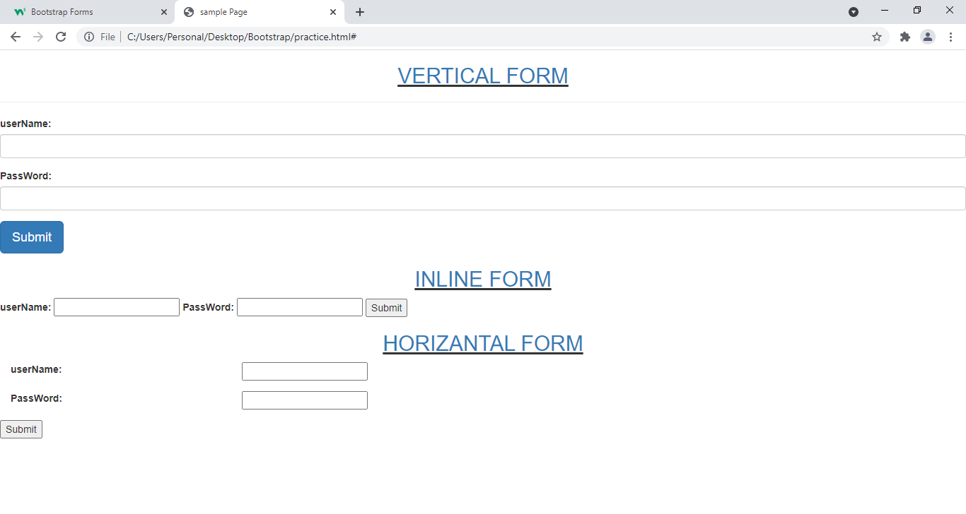

Difference among 3 forms.

7.4) supported controls:- The following form elements support to above 3 form layouts.

1)<input>

2)<textarea>

3)checkbox

4)radio

5) select .

7.4.1) <input>:- This element support for text,password,time,week,month,number,url,email,search,color,file.

7.4.2)<textarea>:- It receives multiple lines of text.

Ex:-<textarea class=”form-control” row=integernumber></textarea>

7.4.3)<checkbox>:- It is used for selecting one (or) more options from list.

7.4.4) Radio:- It is used for selecting only one option from several options.

7.4.5) Static control:- When you need to place plain text next to form lablel with in form, use .form-control-static class with <p> element.

Example:

7.4.6)helptext:- This is help text for form-controls. Help text should explicitly be associated with form-control using aria-described attribute.

* It helps to screen readers when they enters form-control.

Example:

7.4.7) Validation styles:- Bootstrap includes validation styles for error,waring and success states on form controls. To use add .has-success,has-warn,has-error to parent element of control element.

7.4.8) control-sizing:-

A) set height of form elements using .input-lg and .input-sm classes on vertical form layout.

Examples:-

b) set height of form elements using form-group-lg,form-group-sm classes on horizontal form layout.

Examples:-

8)Buttons:- we use button class on <a>,<button> (or) <input> element.

8.1) <a> :- If button class is added to <a>, link becomes button. When button is pressed we navigate to another page or section with in same document. Bootstrap applies its own styles to anchor content.

8.2) <button>:- to apply bootstrap styles on button, we should add btn class to <button> element.

Notes:- 1) when we press button, it is highlited with blue color.

2) bootstrap removes left,top margins.

3) bootstrap button height is more than normal button.

4)Inside area of button is filled with light gray color.

8.3) <input> we add btn class to <input type=submit|clear|button> when bootstrap css styles will be applied to button.

8.4) styled buttons:- bootstrap provides classes for creating styled buttons . the class are

a)btn-primary

b)btn-success

c)btn-warning

d) btn-danger

e)btn-info

f) btn-default.

8.5) button-sizes:- Bootstrap provided 3 classes for creating large button, small button and extra small button. The classes are

a)btn-lg

b)btn-sm

c)btn-xs.

8.6)Block-level-buttons:- The block level button occupies full width of its parent element. To crete block-level-button, we should add btn-block class to <a>,<button> (or) <input> element.

8.7) disables:- The bootstrap styled button is disabled by adding disabled attribute to <button>,<a> or <input> element.

Example:-

<body>

<h2> Buttons</h2>

<button class="btn btn-primary btn-xs">abc</button>

<button class="btn btn-primary btn-block btn-xs">abc</button>

<button class="btn btn-danger disabled btn-xs">abc</button>

<a href="#" class="btn btn-success btn-sm">link</a>

<input type="submit" name="input" class="btn btn-warning btn-lg"/>

</body>

Output:

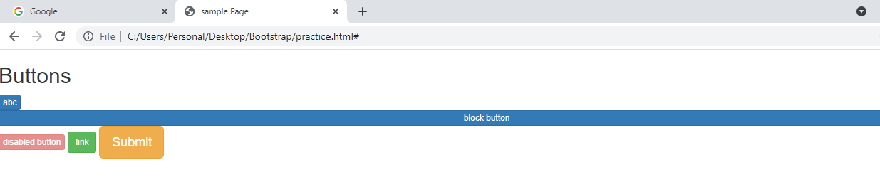

8.8) Button Groups:- The button group classes can be used to style <a>,<input> and <button> elements.

a).btn-group:- This class groups button together on single line.

Syntax:-

<div class=”btn-group”>

<button class=”btn”> content</button> (or)

<input type=” submit|clear” class=”btn”> content</button|a|input>(0r)

<a href=”” class=”brn”>content</a>

</div>

Example:-

<body>

<div class="btn-group">

<button class="btn btn-primary ">abc</button>

<a href="#" class="btn btn-success ">link</a>

<input type="submit" name="input" class="btn btn-warning "/>

</div>

</body>

Output:

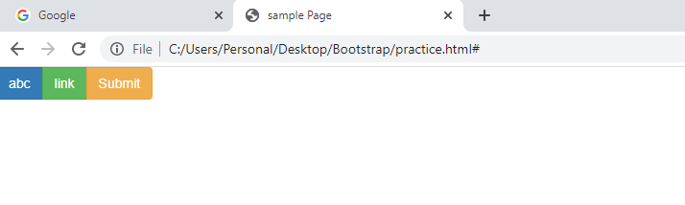

b)btn-toolbar:- This class groups buttons together on single line. It leave left-margin to every button so that there is gap between any two adjacent buttons in toolbar.

Example:-

<body>

<div class="btn-group">

<button class="btn btn-primary ">abc</button>

<a href="#" class="btn btn-success ">link</a>

<input type="submit" name="input" class="btn btn-warning "/>

</div>

</body>

Output:

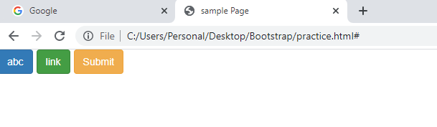

C)btn-group-*:- instread of add button-sizing class to every button in group,Just add btn-group-* class to <div> element.

There are 3 button-group classes. These are

a)btn-group-lg

b) btn-group-sm

c) btn-group-xs

Example:-

<body>

<div class="btn-toolbar btn-group-lg">

<button class="btn btn-primary ">abc</button>

<a href="#" class="btn btn-success ">link</a>

<input type="submit" name="input" class="btn btn-warning "/>

</div>

Output:-

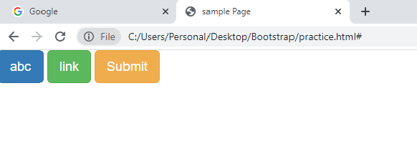

d)vertical variation:- btn-group-vertical class display group of buttons vertically rather than horizontally. Split button drop down is not allowed in vertical alignment.

Example:-

<body>

<div class="btn-toolbar btn-group-lg btn-group-vertical">

<button class="btn btn-primary ">abc</button>

<a href="#" class="btn btn-success ">link</a>

<input type="submit" name="input" class="btn btn-warning "/>

</div>

</body>

Output:

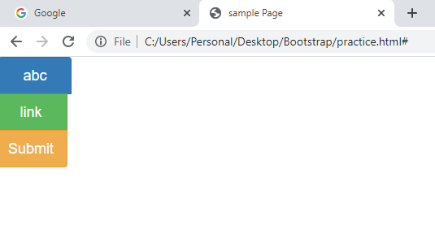

8.9) Button DropDown and Button DropUp:- The drop down , drop up menu allows the user to select one value from predefined list.

Steps to create drop down menu and drop up menu.

1. Add .dropdown (0r) dropup class to <div> element.
2. To open drop-down menu, use button with class .dropdown-toggle and data-bs-toggle=”dropdown|dropup” attribute.
3. .Dropdown-menu class should be added to <ul>(or)<ol> to construct dropdown or dropup menu.
4. .dropdown-item class should be added to every <li> element.

8.9.1)Drop-down divider:- .divider class is used to separate items in a menu with thin horizontal border.

Syntax:-<li class=”divider></li>

8.9.3) disable&active menu items:- Highight dropdown item with .active class(This calss adds blue background color).

Syntax:-<li class=”active”>item name</li>

Disable dropdown item with .disabled class.

Syntax:-<li class=”disabled”>item name</li>

Example:-

<body>

<div class="dropdown">

<button class="btn btn-primary dropdown-toggle" data-toggle="dropdown">Open DropDown</button>

<ul class="dropdown-menu">

<li><a href="#" class="dropdown-item">one</a></li>

<li class="divider"></li>

<li><a href="#" class="dropdown-item">two</a></li>

<li class="divider"></li>

<li><a href="#" class="dropdown-item">three</a></li>

</ul>

</div>

</body>

Output:

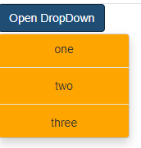

9) Images:- images can be made responsive-friendly by adding .img-responsive class to <image>element. This class applies following styles to image on all types of devices.

Ex:-<img src”=” class=”img-responsive” alt=”_target”/>

9.1) Image shapes:- Bootstrap provided 3 classes to style images. The classes are

1)img-rounded

2) img-circle

3)img-thumbnail .

These classes should only be added to <img> element.

Example:-

<body>

<img src="C:\Users\Personal\Desktop\Bootstrap\images\mlec.png" class="img-rounded">

<img src="C:\Users\Personal\Desktop\Bootstrap\images\mlec.png" class="img-circle">

<img src="C:\Users\Personal\Desktop\Bootstrap\images\mlec.png" class="img-thumbnail">

</div>

</body>

Output:-

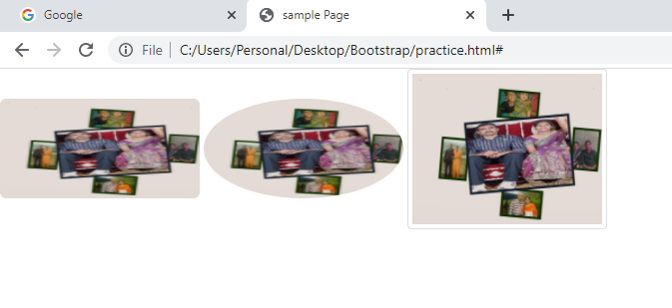

10) Helper classes:

10.1) Glyphicons:- Bootstrap provides 260 glyphicons from glyphicons set. These glyphicons can b used in text,buttons,toolbars,navigations,forms etc.. .

Some examples:- 1) Envelope glyphicon.

2)Download glyphicon.

3)Search Glyphicon.

Syntax: <span class=”glyphicon glyphicon-name”> content</span>

Example:-<span class=”glyphicon glyhicon-envelope”> content</span>

Note:- Glyphicons are available upto bootstrap3.

10.2) close icon:- The class create close icon and it place close icon at top right corner in container element. The class name is close.

Example:-<button class=”close”>&times;</button>

The close icon is used in alerts.

10.3) caret:- The caret indicates drop down and drop up functionality and direction.

Syntax:-<span class=”caret”></span>

10.4) show:- It forces an element to be shown with .show class or .visisble class.

Syntax:-<tagname class=”show”> content</tagname>

The following clases are used to show element by device via media queries. The classes are

Picture.

10.5)hidden:- Forces an element to be hidden with .hidden class. It is deprecated tag in v3.0.1.

11. Nav:

11.1) Nav:- The .nav class , .nav-item and .nav-link classes creates very flexible nav components.

11.2) Nav-tab:- This class dispalys navigation elements as tabs and put navigation elements next to each other, instead of vertically being stacked.

Note: when you place cursor on any navigation element,only that element is highlighted with light gray color.

11.3) nav-pill:- This class displays navigation elements as pills and put navigation elements next to each other.

11.4)Difference between nav-tabs and nav-pills

Nav-tabs nav-pills

1. Navigation element is only <a>element. A) navigation element can be made with <a>and <

Button> element.

1. A line is located under the tabs bar. B) a line is not located under the line.

Ex:- App PIC xyz Ex:- App PIC xyz

11.5) Justified:- The tabs or pills equally shares width of its parent on screen wider than 768 px with nav-justified class.

On screen size <768 px, tabs and pills are located vertically.

.justify-content-center , .justify-content-left,.justify-content-right classes are used to align the navigation elements.

11.6) disabled:- This disabled is used to make disable the navigation element tab or pill. The disabled navigation element is inlight gray color.

Example:-

<body>

<u><h3 class="text-center">Navigation bar is created using the nav element</h3></u>

<nav class="nav justify-content-center">

<a href="#" class="nav-item nav-link ">suku1</a>

<a href="#" class="nav-item nav-link">suku2</a>

<a href="#" class="nav-item nav-link">suku3</a>

<a href="#" class="nav-item nav-link disabled">suku4</a>

</nav>

<u><h3 class="text-center">Navigation bar is created using the order list</h3></u>

<ol class="nav nav-justifed ">

<li class="nav-item"><a href="#" class="nav-link ">suku1</a></li>

<li class="nav-item"><a href="#" class="nav-link">suku2</a></li>

<li class="nav-item "><a href="#" class="nav-link disabled">suku3</a></li>

<li class="nav-item"><a href="#" class="nav-link">suku4</a></li>

</ol>

<u><h3 class="text-center">Navigation elements as tabs </h3></u>

<ol class="nav nav-justifed nav-tabs">

<li class="nav-item "><a href="#" class="nav-link active">suku1</a></li>

<li class="nav-item"><a href="#" class="nav-link">suku2</a></li>

<li class="nav-item "><a href="#" class="nav-link disabled">suku3</a></li>

<li class="nav-item"><a href="#" class="nav-link">suku4</a></li>

</ol>

<u><h3 class="text-center">Navigation elements as pills </h3></u>

<ol class="nav nav-pills">

<li class="nav-item "><a href="#" class="nav-link active">suku1</a></li>

<li class="nav-item"><a href="#" class="nav-link">suku2</a></li>

<li class="nav-item "><a href="#" class="nav-link disabled">suku3</a></li>

<li class="nav-item"><a href="#" class="nav-link">suku4</a></li>

</ol>

</body>

Output:-

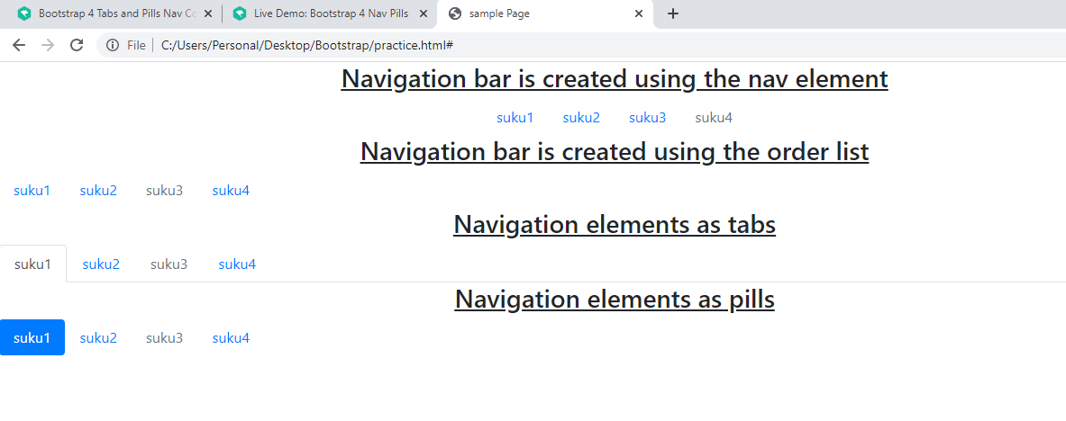

11.7)Nav bar:-  A website's navigation bar, which includes the page names and links to them and a search box tailored to user needs, is a crucial element.

Syntax:1

<nav class=”navbar[ navbar-expand-xs|sm|md|lg|xl|xxl ] [fixed-top|fixed-bottom|sticky-top]>

<ul/ol class=navbar-nav >

<li class=”nav-item”><a class=”nav-link”>…</a></li>

<li class=”nav-item”><a class=”nav-link”>…</a></li>

</ul>

<nav>

Note:- if u place navbar-expand-* then horizontal nav bar will be created. Otherwise vertical nav bar will be created.

Syntax:2 navbar with Logo As link.

<nav class=”navbar[ navbar-expand-xs|sm|md|lg|xl|xxl ] [fixed-top|fixed-bottom|sticky-top]>

<div class=”container-fluid>

<a href=’ ‘ class=’ navbar-brand‘><img src=” “></a>

<ul/ol class=navbar-nav >

<li class=”nav-item”><a class=”nav-link”>…</a></li>

<li class=”nav-item”><a class=”nav-link”>…</a></li>

</ul>

<nav>

Syntax:3

**Toggle Navbar**:- The toggle navbar helps to create a responsive function for all sizes of devices. The navbar shows on large-size devices with default size. If the device's screen is xl or sm size, then the toggle button shows on the screen. This button works as a dropdown with a nav link.

**<nav** class = "navbar bg-dark navbar-dark navbar-expand-sm"**>**

**<button** class="navbar-toggler" type="button" data-bs-toggle="collapse" data-bs-target="#collapsible"**>**

**<span** class="navbar-toggler-icon"**></span>**

**</button>**

**<div** class="collapse navbar-collapse" id="collapsible"**>**

**<ul** class = "navbar-nav me-auto"**>**

//list item!

**</ul>**

**</div>**

**</nav>**

Example:

<body>

    <h2> horizantal navigation bar</h2>

    <div class = "container mt-2">

        <h4> Basic Navbar Function </h4>

        <nav class = "navbar navbar-expand-lg bg-dark justify-content-center">

        <div class = "container-fluid">

        <ul class = "navbar-nav">

        <li class = "nav-item">

        <a class = "nav-link" href = "#"> First </a>

        </li>

        <li class = "nav-item">

        <a class = "nav-link" href = "#"> Second </a>

        </li>

        <li class = "nav-item">

        <a class = "nav-link" href = "#"> Third </a>

        </li>

        <li class = "nav-item">

        <a class = "nav-link" href = "#"> Fourth </a>

        </li>

        </ul>

        </div>

        </nav>

    <h2>vertical navigation bar</h2>

    <div class = "container mt-2">

        <h4> Basic Navbar Function </h4>

        <nav class = "navbar  bg-dark fixed-bottom">

        <div class = "container-fluid">

        <ul class = "navbar-nav">

        <li class = "nav-item">

        <a class = "nav-link" href = "#"> First </a>

        </li>

        <li class = "nav-item">

        <a class = "nav-link" href = "#"> Second </a>

        </li>

        <li class = "nav-item">

        <a class = "nav-link" href = "#"> Third </a>

        </li>

        <li class = "nav-item">

        <a class = "nav-link" href = "#"> Fourth </a>

        </li>

        </ul>

        </div>

        </nav>

</body>

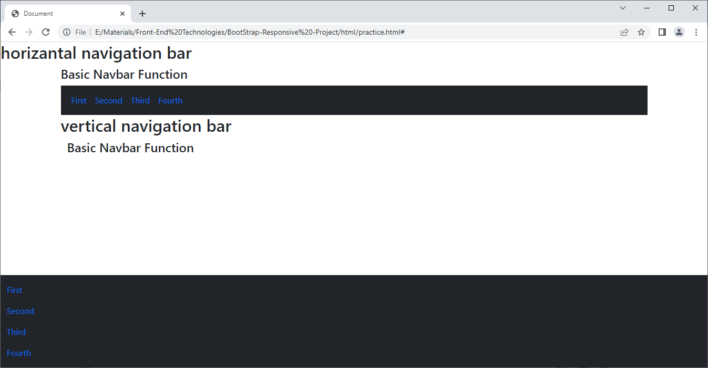

h) .navbar-text:- this class place the element inside navbar at center in vertical direction.

Example:-

<body>

<br>

<u class="text-center">Navigation bar is fixed at bottom of screen</u>

<nav class="navbar navbar-expand- lg navbar-inverse navbar-fixed-top">

<div class="navbar-header">

<a class="navbar-brand" href="#"></i>WebSiteName</a>

</div>

<ul class="navbar-nav ">

<li><a href="#">one</a></li>

<li><a href="#">two</a></li>

<li><a href="#">three</a></li>

<li><a href="#">four</a></li>

<p class="text-primary">This is sukumar</p>

</ul>

</nav>

<h4 class="text-warning"> In above nav bar paragraph element is not vartically aligned.</h4>

<nav class="navbar navbar-expand-sm navbar-inverse navbar-fixed-bottom">

<div class="navbar-header">

<a class="navbar-brand" href="#"></i>WebSiteName</a>

</div>

<ul class=" navbar-nav ">

<li><a href="#">one</a></li>

<li><a href="#">two</a></li>

<li><a href="#">three</a></li>

<li><a href="#">four</a></li>

<p class="navbar-text text-danger">This is sukumar</p>

</ul>

</nav>

</body>

Output:-

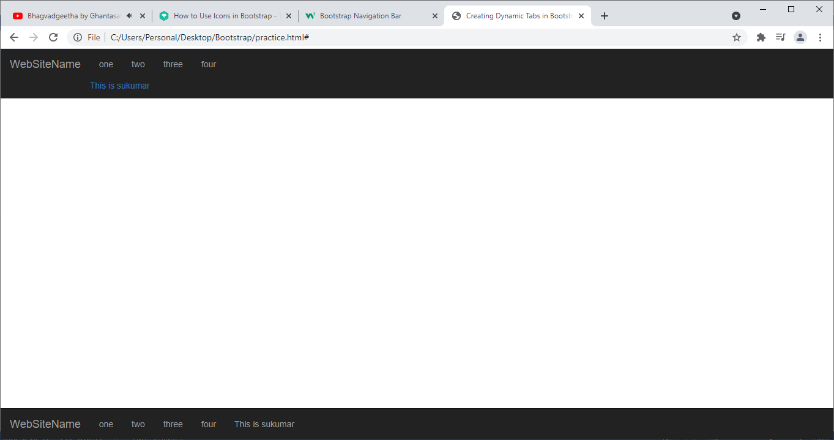

i) .navbar-btn:- this class vertically centers button inside navbar.

j) .navbar-form:- This class adds form elements in navbar and vertically center them.

Example:-

<body>

<br>

<u class="text-center">Navigation bar is fixed at bottom of screen</u>

<nav class="navbar navbar-inverse navbar-fixed-top">

<div class="navbar-header">

<a class="navbar-brand" href="#"></i>WebSiteName</a>

</div>

<ul class="nav navbar-nav">

<li><a href="#">one</a></li>

<li><a href="#">two</a></li>

<li><a href="#">three</a></li>

<li><a href="#">four</a></li>

</ul>

<form action="#" class="navbar-form">

<div class="form-group">

<label for="#one" class="text-primary">UserName:</label>

<input type="text"/>

</div>

<button class="btn btn-primary">Search</button>

</form>

</nav>

</body>

</html>

Output:-

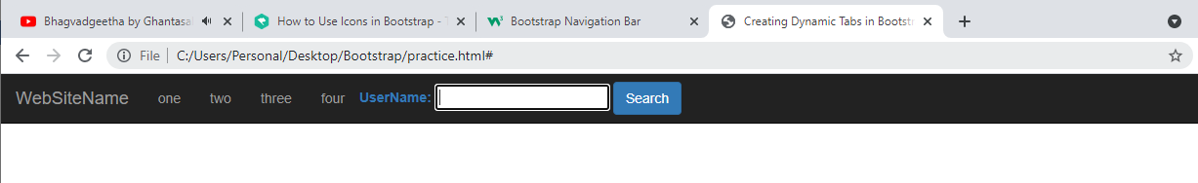

11.8)Navigation Tabs:- You can activate a tab component without writing any JavaScript — simply specify the data-toggle="tab" on each tab, as well as create a .tab-pane with unique ID for every tab and wrap them in .tab-content.

Example:-

<div>

<ul class="nav nav-tabs">

<li class="nav-item"><a href="#one" class="nav-link " data-toggle="tab">one</a></li>

<li class="nav-item"><a href="#two" class="nav-link" data-toggle="tab">two</a></li>

<li class="nav-item"><a href="#three" class="nav-link" data-toggle="tab">three</a></li>

<li class="nav-item"><a href="#four" class="nav-link disabled" data-toggle="tab">four</a></li>

</ul>

<div class="tab-content">

<div class="tab-pane active" id="one"><p>This is sukumar</p></div>

<div class="tab-pane" id="two"><p>This is samrajyam</p></div>

<div class="tab-pane" id="three"><p>This is veena</p></div>

<div class="tab-pane" id="four"><p>This is sulamaha</p></div>

</div>

</div>

Output:-

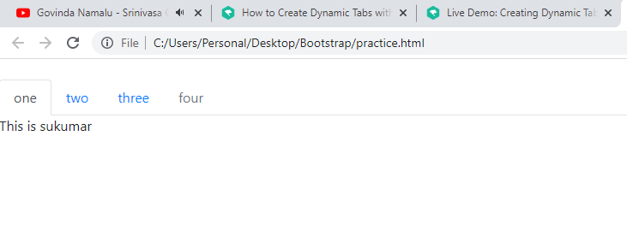

12) BreadCrumb:- Bread crumb indicates current location of webpage with in navigation hierarchy of website/web-application.

Example:-

* The bread crumb class remove browser default styles to <ul>
* Every item in unordered list is breadcrumb.
* If ‘/’ is not between any two adjancent bread crumbs, then we should add breadcrumb-item class to every <li> element except last <li> element.

Example:

------------

<body>

<ul class="breadcrumb">

<li class="breadcrumb-item">C:</li>

<li class="breadcrumb-item">Bootstrap</li>

<li class="breadcrumb-item">Hrml</li>

<li class="breadcrumb-item">practice</li>

</ul>

</body>

Output:

----------

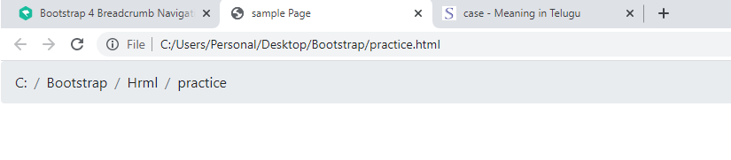

13) Pagination:- The pagination is used to indicate set of related content across multiple pages and enable navigation across them.

When we assign .pagination class to <ul> element, it removes default browser styles to <ul> element. The .pagination class aligns list items horizontally and draw rounded corner box around list.In box,list items are separated by divider . The .pagination class vertically center aligns items in boxes.

13.1)Pagination-color:- The class name is pg-colorname . this class should added to<ul> element. This class changes the background color of pagination.

Ex:-<ul class=”pagination pg-red”>

13.2) sizing:- There are two classes for creating large pagination and small pagination. The classes are

a)pagination-lg

b) pagination-sm

c)pagination-md

13.3) alignment:- Change alignment of pagination components with justify-content-center,justify-content-end classes. These classes are added to<ul> element.

13.4)disabled and active states:-

.active indicates that pagination item is clickable.

.diabled class make content as unclickable.

Example:-

<body>

<p class="text-center">Example-1</p>

<div class="pagination">

<p class="page-item "><a href="#" class="page-link">Rock</a></p>

<p class="page-item "><a href="#" class="page-link">Bootstrap</a></p>

<p class="page-item "><a href="#" class="page-link">Hrml</a></p>

<p class="page-item "><a href="#" class="page-link">practice</a></p>

</div>

<p class="text-center">Example-2</p>

<ul class="pagination pagination-lg">

<li class="page-item active"><a href="#" class="page-link">1</a></li>

<li class="page-item"><a href="#" class="page-link">2</a></li>

<li class="page-item"><a href="#" class="page-link">3</a></li>

<li class="page-item disabled"><a href="#" class="page-link">4</a></li>

</ul>

</body>

Output

----------

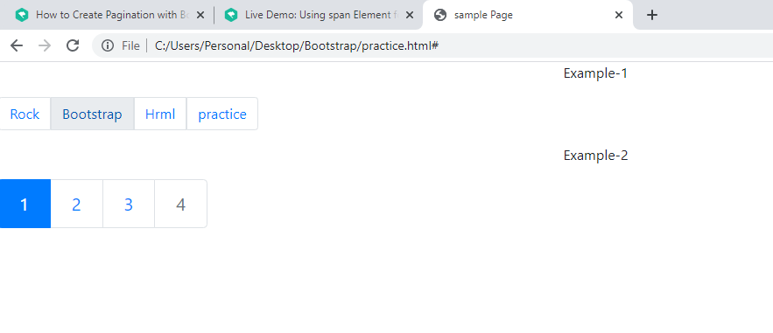

14. Badge:- Badge is number . It is used as part of button and link. It indicates no.of received messages, no.of unread messages,no.of notifications..etc. Badge is commonly used in social networking websites and email applications.

Badge is associated with <a>,<button> and other elements.

* .badge:- use .badge class with in <span> element to create badge.

Ex:-<a href=”#”>App<span class=”badge”>7</span></a>

* The badge contextual classes are badge-primary,badge-secondary,badge-danger,badge-success,badge-warning,badge-info,badge-light,badge-dark.
* .rounded-circle is class name. It is used pill shape badge.

Ex:-

<body>

<button class="btn btn-success">UnRead <span class="badge badge-success">7</span></button>

<br>

<a href="#" title="Click me">Notification:<span class=" badge badge-pill badge-dark">new</span></a>

</body>

Output:

----------

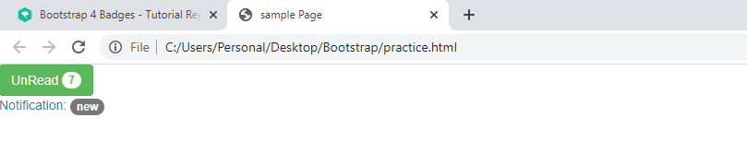

15. Labels:- label is used to depict essential information which is crucial to understand such as important messages and notes.

(or)

Label provides additional information about something.

Syntax:-<span class=”label label-default”> labelname</span>

The following are label contextual color classes.

1. Label-default
2. label-primary
3. label-danger
4. label-warning
5. label-info
6. lable-success.

16. progress bar:- The progress bar shows status of work flow (or) action.

16.1) .Progress:- This class should be added to container. It displays only empty solid bar. This bar contains progress bars.

<body>

<div class="progress">

</div>

Output:

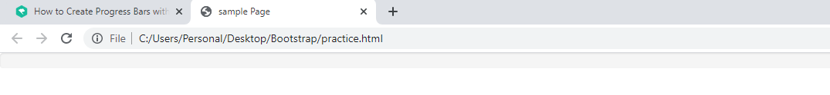

16.2) .progress-bar:- This class creates progress bar inside empty solid bar.

16.3) colored progress bar:- The following contextual classes are used with progress bar.

a) progress-bar-success

b) progress-bar-info

c) progress-bar-warning

d)progress-bar-danger

16.4)stripped progress bar:- The following class is used to create stripped progress bar. The class name is .progress-bar-striped.

16.5) Animated progress bar:- progress-bar-animated class to animate stripes right to left.

16.6) we can create many progress-bars in single empty solid bar.

Example:1

<body>

<div class="progress">

<div class="progress-bar bg-success" style="width:50%">50% completed</div>

</div>

<br>

<div class="progress">

<div class="progress-bar progress-bar-striped bg-warning" style="width:60%">60% completed</div>

</div>

<br>

<div class="progress">

<div class="progress-bar progress-bar-striped progress-bar-animated bg-danger" style="width:60%">60% completed</div>

</div>

<u><h3 class="text-center text-info">Stacked progress bar</h3></u>

<div class="progress">

<div class="progress-bar bg-success" style="width:50%">50% completed</div>

<div class="progress-bar progress-bar-striped bg-warning" style="width:25%">60% completed</div>

<div class="progress-bar progress-bar-striped progress-bar-animated bg-danger" style="width:25%">60% completed</div>

</div>

</body>

Output:

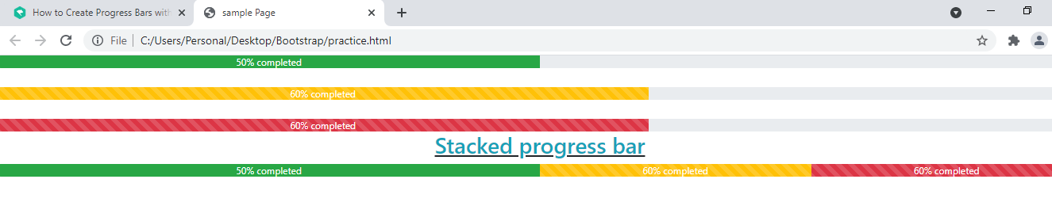

17) alert:- Bootstrap provides easy way to create predefined alert messages. Alerts are created with .alert class followed by one of four conceptual class. The conceptual classes are .alert-success,.alert-warning,.alert-danger, .alert-info.

Examle:-

17.1) .Alert-link:- This class is added to <a> element. The <a> element should be put in alert box, when alert-box message text color and <a> element content color will be same.

But alert-box message text font size weight is vary from <a> element content color.

When you put cursor on <a> element content, it si underlined.

Example:-

17.2) closing alerts:-

a) Add .alert-dismissable class to alert container.

b) Add class=”btn-close” and data-bs-dismiss=”alert” to <a> (or) <button> element.

Example:-

<div class="alert alert-warning alert-dismissible fade show" >

    <strong>Holy guacamole!</strong> You should check in on some of those fields below.

    <button type="button" class="btn-close" data-bs-dismiss="alert" ></button>

  </div>

18. Jumbotron:- Jumbotron is displays as gray color box with rounded corners. It occupies full width of viewport. We can emphasize key content or important info on web page using jumbotron. The important information or key content is show cased in grey color box.

Inside jumbotron, we can put any valid HTML elements,bootstrap classes. When you place text inside jubotron, the jumbtron class enlarges font-size of text.

Jumbotron inside container

Syntax: <div class=”container”>

<div class=”jumbotron”>

---

---

</div>

</div>

Jumbotron-fluid: this class removes rounded corners to jumbotron.

Syntax:-<div class=”jumbotron jumbotron-fluid”>

---

</div>

Example:-

<body>

<div class="jumbotron">

<p>Once upon a time , there are two student studied doctor course. One of them is now in us. Another person is in mumbai. both are

servicing to poop people. To see their photo press the button.</p>

<button clas="btn btn-success btn-lg">Press Me</button>

</div>

<div class="jumbotron container">

<p>Once upon a time , there are two student studied doctor course. One of them is now in us. Another person is in mumbai. both are

servicing to poop people. To see their photo press the button.</p>

<button class="btn btn-success btn-lg">Press Me</button>

</div>

</body>

Output:

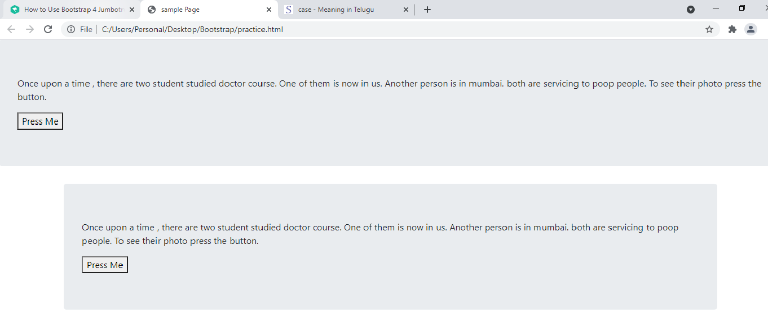

19) card:- A card in Bootstrap 4 is a bordered box with some padding around its content. It includes options for headers,body, footers, content, colors, etc.

Example:

<body>

 <div class="card" style="width:200px">

    <h3>Basic Card</h3>

    <div class="card-header">This is sukumar</div>

    <div class="card-body">I Love India</div>

    <div class="card-footer">@tunishk</div>

 </div>

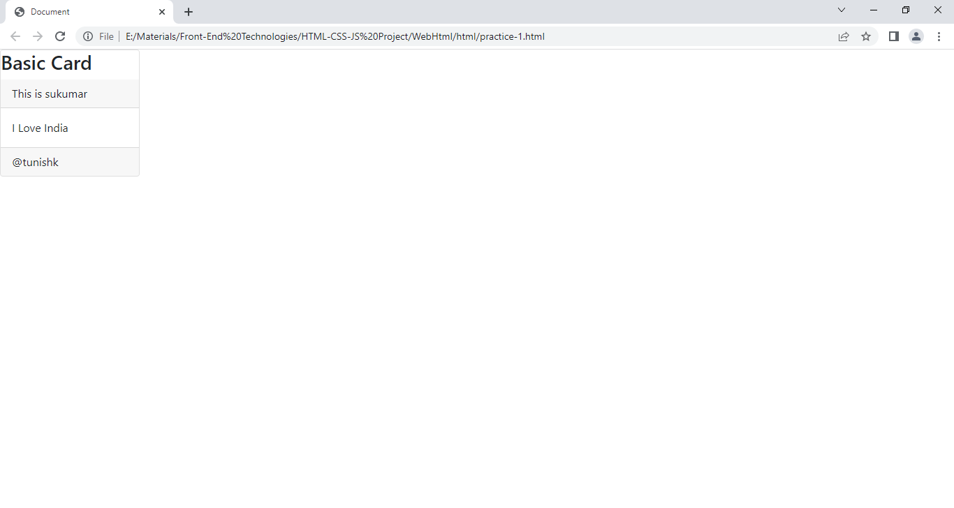

19.1.Title,.link,.text , .stretched-link:-

We use .title class to add title to any heading element.

The .link class adds blue color to link and hover effect.

The .text class remove bottom margin to <p> element, if it is last element in card-body.

Add the .stretched-link class to a link inside the card, and it will make the whole card clickable and hoverable.

Example:

<body>

 <div class="card" style="width:500px">

    <h3>Basic Card</h3>

    <div class="card-header">

      <p class="card-title">Inforation</p>

      <hr>

      <p class="card-text" >This is sukumar.</p>

    </div>

    <div class="card-body">I Love India</div>

    <div class="card-footer">@tunishk

      <a href="" type="btn btn-sm btn-outline-danger card-link">Gosome where</a>

    </div>

 </div>

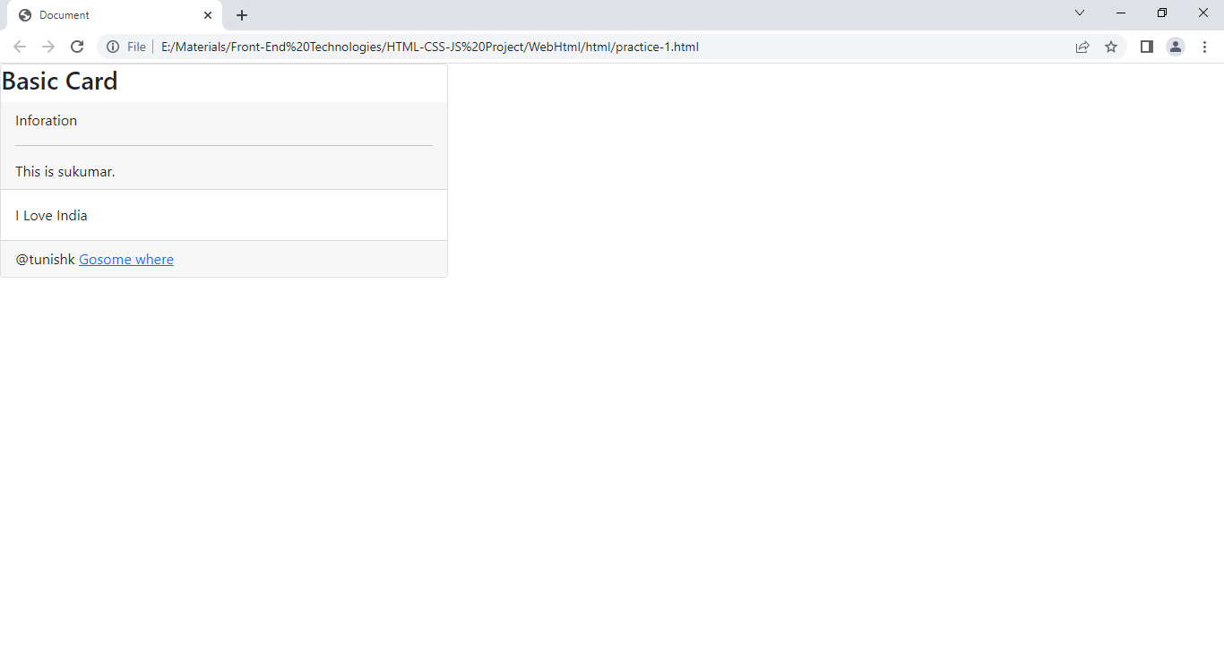

19.2. Card Image Overlays: Turn an image into a card background and use .card-img-overlay to add text on top of the image.

 <div class="card" style="width:400px;height:300px">

       <h3 class="text-center text-success ">Bio-Data</h3>

       <div class="card-header">

        <img class="" width="100%" height="75px" src="https://images.unsplash.com/photo-1488426862026-3ee34a7d66df?ixlib=rb-4.0.3&ixid=MnwxMjA3fDB8MHxzZWFyY2h8MTF8fG1vZGVsfGVufDB8fDB8fA%3D%3D&w=1000&q=80" alt="Card image" style="width:100%">

        <p class="card-img-overlay ">She is famous model in india. She born in Gujarath. her passion is modiling child hood onwards.</p>

      </div>

      <div class="card-body">

        <h4 class="card-title">John Doe</h4>

        <p class="card-text">Some example text some example text. John Doe is an architect and engineer</p>

        <a href="#" class="btn btn-primary text-link stretched-link">See Profile</a>

      </div>

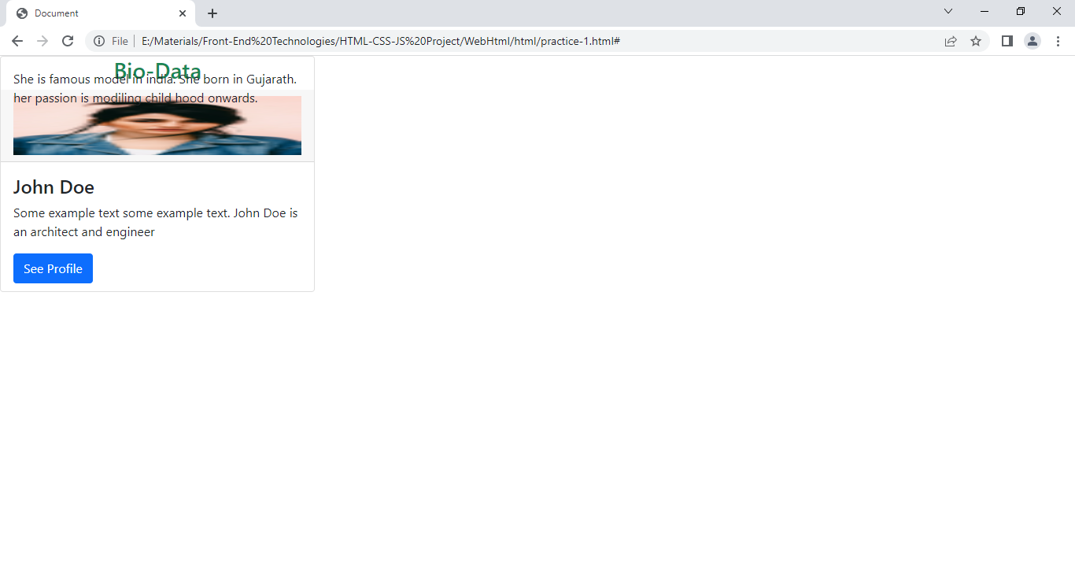

19.3card-deck: The .card-deck class creates a grid of cards that are of **equal height and width**. The layout will automatically adjust as you insert more cards.

**Note:** The cards are displayed vertically on small screens (less than 576px):

19.4: card-group: The .card-group class is similar to .card-deck. The only difference is that the .card-group class removes left and right margins between each card.

**Note:** The cards are displayed vertically on small screens (less than 576px), **WITH** top and bottom margin

20) Pager:- The pager places all list items in row horizontally and make centerally them.

Example:-

1. Create previous and next links in page using pager.

<ul class=”pager”>

<li><a href=”#”>previous</a></li>

<li><a href=”#”>next</a></li>

</ul>

When u place mouse pointer over links, they are highlighted with light grey background color.

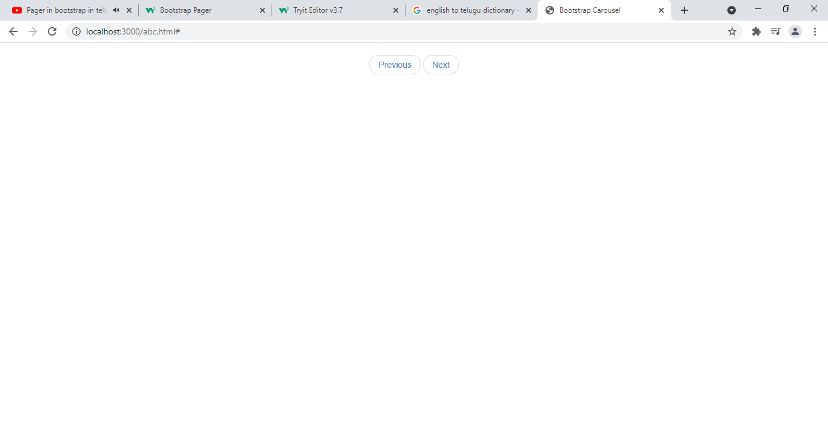

1. Create previous and next buttons in page using pager.

<ul class=”pager”>

<li><button class=”btn btn-primary”>previous</button></li>

<li><button class=”btn btn-warning”>next</button></li>

</ul>

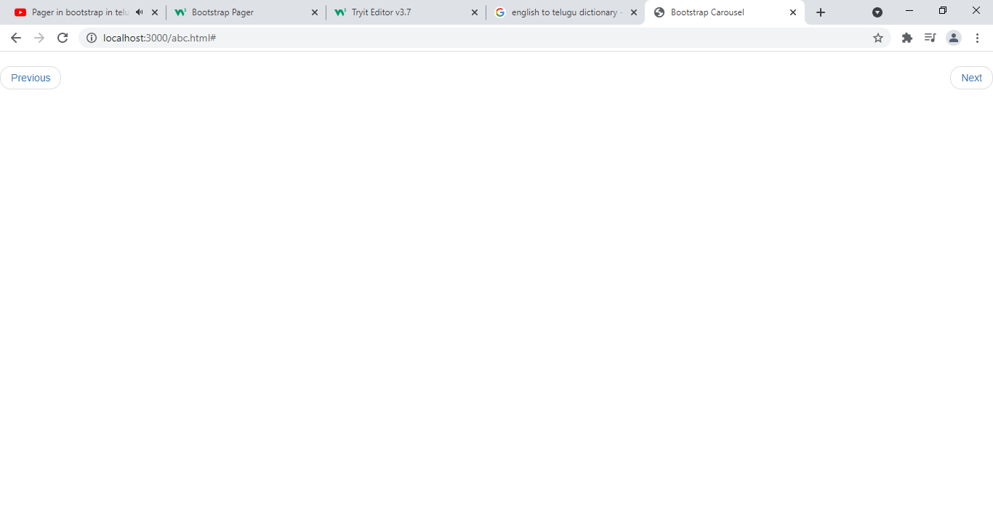

1. Align two buttons or links:-

.previous:- This class put list item at extreme left side of row.

.next:- this class put list item at extreme right side of rwo.

Ex:-

<ul class=”pager”>

<li class=”previous”><button class=”btn btn-primary”>previous</button></li>

<li class=”previous”><button class=”btn btn-warning”>next</button></li>

</ul>

21) carousel plug-in in bootstrap5:- The carousel is slide show for cycling thorough series of content built with css 3D transforms and it of java script

It works with series of images or text. It also includes previous/next controllers and indicators.

21.a)Part-1:-

a).carousel:- the .carousel class creates carousel. The ,div class=”carousel”> specifies that <div> contains carousel.

b)caurousel reqires id . That id is needed by carousel controls to function properly.

c).slide:- This clas adds css transitions and animation effect which makes item slide when showing new item. This class should be added to container(<div>).

d) data-bs-ride=”carousel” attribute tells bootstrap to being animating carousel when page loads.

Ex:-<div class=”carousel slide” data-bs-ride=”carousel” id=”suku”>

21.b) Part-2:-

The indicators are little dots which is at bottom of each slide (which indicates how many slides are in carousel, which slide user is currently viewing.

The indicators are specified in <ol> element with class .caurosel-indicators.

1. *data-target:- This attribute points to id of carousel.
2. *data-bs-slide-to:- This attribute specifies which slide to go to when clicking on specified dot.

Ex:-<ol clas=”carousel-indicators”>

<li data-bs-target=”suku” data-bs-slide-to=”0”></li>

<li data-bs-target=”suku” data-bs-slide-to=”1”></li>

</ol>

21.c)Part-3:-

The <div class=”carousel-inner”> specifies that all slides are wrapped in <div>

1. .carousel-inner is container for slides.
2. The content of each slide is defined in inner <div> with .carousel-item class. The content is image (or) text.
3. .active class should be added to any one slide. Otherwise caurosel will not be displayed.

EX:-<div class=”carousel-inner”>

<div class=”carousel-item active”>

<img src=” “/>

</div>

<div class=”carousel-item”>

<img src=” “/>

</div>

</div>

21.d) Part-IV

<a class="carousel-control-prev" href="#myCarousel" data-bs-slide="prev">

<span class="carousel-control-prev-icon"></span>

</a>

<a class="carousel-control-next" href="#myCarousel" data-bs-slide="next">

<span class="carousel-control-next-icon"></span>

</a>

21.e) part-V:-

Caption to slides:- This is an optional part.

Add .carousel-caption to each <div class=”item”> to create captionfor each slide.

Example:-

<div class=”item”>

<img src=” “/>

<div class=”carousel-caption>

<p> sukumar</p>

</div>

</div>

Complete program

<div class="container" >

<div id="myCarousel" class="carousel slide" data-bs-ride="carousel">

<!-- Carousel indicators -->

<ol class="carousel-indicators">

<li data-bs-target="#myCarousel" data-bs-slide-to="0" class="active"></li>

<li data-bs-target="#myCarousel" data-bs-slide-to="1"></li>

<li data-bs-target="#myCarousel" data-bs-slide-to="2"></li>

</ol>

<!-- Wrapper for carousel items -->

<div class="carousel-inner border">

<div class="carousel-item active">

<img src="two.jpg" style="max-height:250px;over-flow:hidden;width:100%">

</div>

<div class="carousel-item">

<img src="three.jpg" style="max-height:250px;over-flow:hidden;width:100%" >

</div>

<div class="carousel-item">

<img src="five.jpg" style="max-height:250px;over-flow:hidden;width:100%" >

</div>

</div>

<!-- Carousel controls -->

<a class="carousel-control-prev" href="#myCarousel" data-bs-slide="prev">

<span class="carousel-control-prev-icon"></span>

</a>

<a class="carousel-control-next" href="#myCarousel" data-bs-slide="next">

<span class="carousel-control-next-icon"></span>

</a>

</div>

</div>

22. Modal:- The modal is a dialog box (or) pop up box. That is displayed on top of current page. Modals are widely used to warn users for situations like session time out or to receive their final confirmation before going to perform any critical actions such as saving or deleting important data.

22.1) part-1:- (Trigger Part)

a) To create trigger modal, we should use link or button.

The link or button element must include two attributes.

*data-bs--toggle=”modal” –It opens modal window.

*data-bs-target=”id of modal”- It points to id of modal.

*data-bs-backdrop=”static”- Usually after opened modal, if u click the mouse outside the modal then modal will be closed automatically. This is default behaviour. This behaviour is cancelled by this attribute.

Ex:-<button data-target=”one” data-toggle=”modal” class=”btn btn-primary”>open Model </button>

22.2)Part-II (Modal part)

1. .Modal:- this class identifies contents of <div> as modal and brings focus to it. This should be in other<div>
2. <div> :- the outer <div> has id which is equal to value ofdata-target in<button>(0r) <a> element.
3. .fade:- This class adds transition effect which fades model in out.
4. .modal-lg,modal-xl,modal-sm,modal-fullscreen which is classes. They changes size of model.
5. .modal-dialog-centered:- The modalis centered vertically and horizontally with inpage.
6. Use css attribute max-width to set width of modal.

Ex:- <div id=”one” class=”modal fade” style=”max-width:npx”>

22.3)Part-III:-

a) .modal-dialog:- It sets proper width and margin of modal.

Example:-<div class=”modal-dialog”>

1. .modal-dialog-scrollable:- It scrolls content of modal.

Example: <div class=”modal-dialog modal-dialog-scrollable>

1. Modal-dialog-fullscreen: it sets model dimension which is equal to view port dimensions.

Example: <div class=”modal-dialog modal-dialog-fullscreen”>

22.4) Part-Iv:-

a) .modal-content:- This class styles the model(border,background color etc).

b) .modal-header:- This class isused to define style for header of modal.

c) . modal-title:- this calss styles header with proper line-height.

d) .modal-body:- This class is used to define styles for body of modal. Add any HTML mark up here; paragrapsh,images,videos etc..

e) .modal-footer:- this class is used to define styles for footer of modal.

Example program

<style>

.navbar{background-color: red;}

</style>

</head>

<body>

<button class="btn btn-lg btn-primary" data-toggle="modal" data-target="#one">Show the Dialog</button>

<div class="modal modal-xl modal-dialog-center" id="one">

<div class="modal-dialog">

<div class="modal-content">

<div class="modal-header">

<nav class="navbar navbar-inverse">

<div class="navbar-heading">

<a href="#" class='navbar-brand'>Welcome Navigation Part</a>

</div>

<ul class="nav navbar-nav">

<li><a href="#">one</a><li>

<li><a href="#">two</a><li>

<li><a href="#">three</a></li>

</ul>

</nav>

</div>

<div class="modal-body" >

<h2 class="text-success"> Sample model heading Body part</h2>

</div>

<div class="modal-footer" >

<button class="btn btn-success">Save</button>

<button class="btn btn-success">Canel</button>

</div>

</div>

</div>

</div>

Output:-

----------

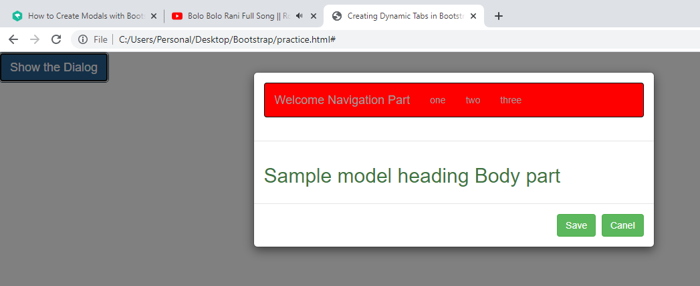

23) Affix:- The affix plug-in allows on element to become locked to an area on page. This plug-in makes element stick at specific area while scrolling up and scrolling down page.

1. data-spy”=affix”:- it adds element you want affixed(locked).

2. data-offset-top/bottom:- both are optional attributes . They shuld be added to elemnt you want locked.

Ex:-

<img src=”#” height=”400px”>

<ul data-spy=”affix” data-offset-top=”20”>

<li>suku</li>

<li>veena</li>

</ul>

Explanation: when we scroll down screen, element are moved towards up. If the <ul> elements moves 20px to wards up, the affix plugin push down 20px towards down and it fixes <ul> at that position.

EX:-

<img src=”#” height=”400px”/>

<ul data-spy=”affix” data-off-set-bottom=”20”>

<li>sukumar</li>

<li>veena</li>

</ul>

When we scroll up screen, elements are moved towards down. If <ul> elements moves 20px towards down, the affix plugin pushup 20 px towards up and if fixes <ul> at that position.

Ex:- .affix{top:250px;}

<img src=”#” height=”700px”/>

<ul data-spy=”affix” data-offset-top=”20”>

<li>suku</li>

<li> veena</li>

</ul>

When </ul> moves 20px toward up, affix plugin places <ul> at 250 px far from top border.

24) Scrollspy:- It is plug-in . It automatically update or highlights navigation element innavigation list based on scroll position.

Steps to create scroll spy:-

Add data-spy=”scroll” to element that should be used as scrollable area.

Ex:- The element is <body>

1. Add data-tartget attribute with value of id or class name of navigationlist to element htat should be used as scrollable.
2. This connects the scrollable area to navigation list.
3. The scrollable elements must match id of links inside navigation list.

Example:-

-----------

25) Tooltip:- A tooltip is a small pop up that appears when user places the mouse pointer over an element such as link or buttons to provide hint or information about the element being hovered.

Step1:- To create a tooltip, you need to add the data-toggle="tooltip" attribute to an element. Tolltip text that would display on hover can be specified using the title attribute.

Syntax:-<tagname data-bs-toggle=”tooltip” title=” “>…</tagname>

Step2:- Tooltips can be triggered via JavaScript — just call the tooltip() Bootstrap method with the id, class or any [CSS selector](https://www.tutorialrepublic.com/css-tutorial/css-selectors.php) of the target element in your JavaScript code.

Syntax:-<script>$(document).ready(function(){

$('[data-toggle="tooltip"]').tooltip();

});

</script>

25.1) Tooltip():-

Syntax:- tooltip({propertyname: value,..});

Properties:-

a)placement:- It sets the position of tooltip. The values are top,bottom,left or right.

b)title:- It sets the default title ,if title attribute is not set. It accepts value. The value is string,html element or function.

c) html: Allow HTML in the tooltip.If true, HTML tags in the tooltip's title will be rendered in the tooltip. If false, jQuery's text() method will be used to insert content into the DOM.

d)animation: it applies css fades to tooltip. It take either true or false.

e) delay:- It’s value is number or object.

Object structure is delay{hide:v1 ,show:v2}

f)hide:- It takes integer value.It hides the tool tip.

g)show:- It takes integer value. It show the toop tip with out placing the mouse on element.

Example:-

<script>

$(document).ready(function(){

$('#one').tooltip('show');

$('#two').tooltip('hide');

$('#three').tooltip({animation:true});

$('#four').tooltip({title:"<h4>I Love U</h4>",html:true});

$('#five').tooltip({delay:{show:0,hide:50}});

});

</script>

</head>

<body>

<a href="#" id="one" data-toggle="tooltip" title="Tooltip shown">Tooltip</a>

<a href="#" id="two" data-toggle="tooltip" title="Tooltip Hidden">Tooltip Hidden</a>

<a href="#" id="three" data-toggle="tooltip" title="Default tooltip">AnimatedTooltip</a>

<a href="#" id="four" data-toggle="tooltip" >CustomTooltip</a>

<a href="#" id="five" data-toggle="tooltip" >Delay Tooltip</a>

</body>

Output:-

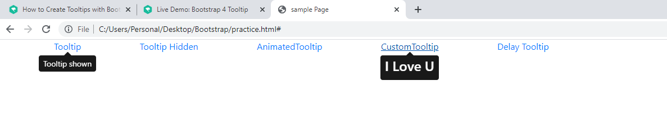

26) PopOver:-popover is small overlay content that is used to display secondary information of element. This popover will apper when user click the element. It disappear when user again click the same element.

Step1:-To create popover , we should add data-toggle=”popover” attribute to element.

Syntax:-<tagname data-toggle=”popover” title=”-“>---</tagname>.

Step2:-Popovers can be triggered via JavaScript — just call the popover() Bootstrap method with the id, class or any [CSS selector](https://www.tutorialrepublic.com/css-tutorial/css-selectors.php) of the required element in your JavaScript code.

Syntax:-<script>$(document).ready(function(){

$('[data-toggle="tooltip"]').popover();

});

</script>

25.1) popover():-

Syntax:- popover({propertyname: value,..});

Properties:-

a)placement:- It sets the position of tooltip. The values are top,bottom,left or right.

b)title:- It sets the default title ,if title attribute is not set. It accepts value. The value is string,html element or function.

c) html: Allow HTML in the popover.If true, HTML tags in the popover's title will be rendered in the tooltip. If false, jQuery's text() method will be used to insert content into the DOM.

d)animation: it applies css fades to popover. It take either true or false.

e) delay:- It’s value is number or object.

Object structure is delay{hide:v1 ,show:v2}

f)hide:- It takes integer value.It hides the popover.

g)show:- It takes integer value. It show the popover with out placing the mouse on element.

Example:-

<script>

$(document).ready(function(){

$('#one').popover('show');

$('#two').popover('hide');

$('#three').popover({animation:true});

$('#four').popover({title:"<h4>I Love U</h4>",html:true});

$('#five').popover({delay:{show:0,hide:50}});

});

</script>

</head>

<body>

<div>

<a href="#" id="one" data-toggle="popover" title="PopoverPopover">Tooltip</a>

<a href="#" id="two" data-toggle="popover" title="Popover Hidden">Tooltip Hidden</a>

<a href="#" id="three" data-toggle="popover" title="Default tooltip">AnimatedTooltip</a>

<a href="#" id="four" data-toggle="popover">Custom PopOver</a>

<a href="#" id="five" data-toggle="popover">Delay PopOver</a>

</div>

</body>

Output:-

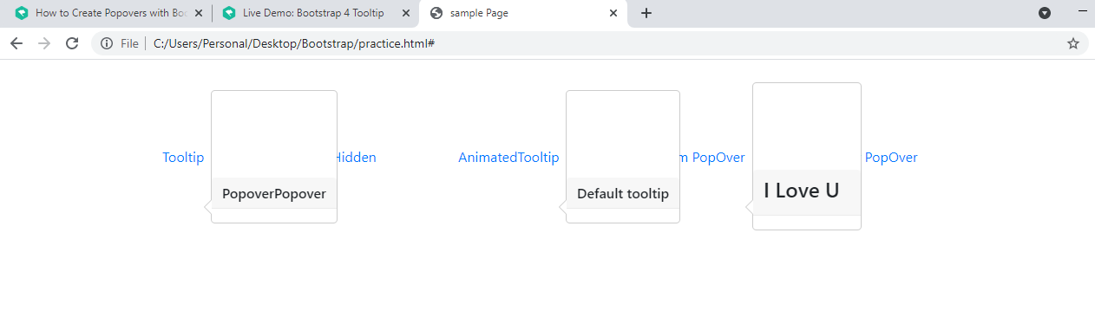

27)spinner:- It is available in bootstrap4.It indicates loading state. There are two types of spinners.

1)border-spinner:- .spinner-border is class name. It is used to create the border spinner.

2)growing spinner:-.spinner-grow is class name. It is used to create the growing spinner.

* We use text contextual classes to apply color to spinner.

* spinner-border-lg,spinner-border-sm,spinner-grow-lg,spinner-grow-sm are class names which is used to create small and large spinners.

Note:- If you place an element inside spinner then it is also rotated along with spinner.

Example:-

<u><h2 class="text-center"> Border-spinner </h2></u>

<div class="spinner-border text-primary spinner-border-lg">

<span class="sr-only">Loading...</span>

</div>

<u><h2 class="text-center"> Growing-spinner </h2></u>

<div class="spinner-grow text-success spinner-border-lg">

<span class="sr-only">Loading...</span>

</div>

Output:-

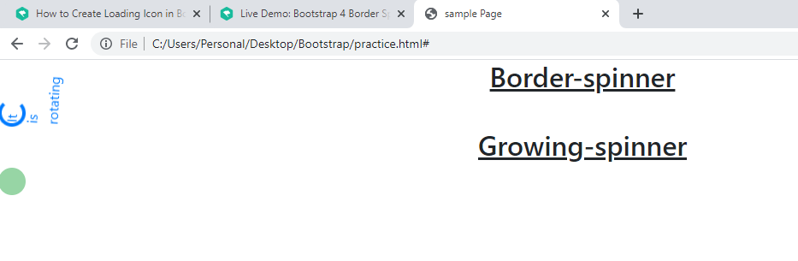

28) Bootstrap Utilities/Helper classes:-

28.1) Float:- The following classes float an element to left ,right or disabling floating based on view port size.

a) .float-left b) .float-right c) .float-none

d) .float-sm-left e) .float-sm-right f) .float-sm-none.

g) .float-xs-left h) .float-xs-right i) .float-xs-none.

j) .float-md-left k) .float-md=right l).float-md-none.

m) .float-lg-left n) .float-lg-right o) .float-lg-none.

p).clearfix

Syntax:-<tagname class=”—“>….</tagname>

28.2) Position:- We following classes to configuring position of element.

a) .fixed-top:- this class place an element a top of viewport.

b) .fixed-bottom:- This class places an element at bottom of view port.

c) .sticky-top:- It places an element at top of view port . But only after you scroll past it.

d) .position-static e) .position-relative f) .position-absolute g) .position-fixed.

Syntax:-<tagname class=”—“ >…</tagname>

28.3) Border:- This utility add or remove elements border.

a) .border:- It adds borders at 4 sides of element.

b) .border-top:- it adds only top border.

c).border-bottom:- it adds only bottom border.

d).border-left:- it adds only left border.

e)border-right:- it adds only right border.

f).border-0:- It does’t add border to element.

g).border-top-0 h) .border-bottom-0 i).border-left-0 j).border-right-0

k)border-primary l)border-info m)border-danger n)border-warning o)border-success

p)border-secondary.

28.3.1) Border-radius classes:- The following class round the border of element.

a) .rounded b) .rounded-top c) .rounded-bottom d) .rounded-start e) rounded-end

f) .rounded-0 g).rounded-circle h) .rounded-pill

28.4) sizing:- we use following utilites to make elements as tall or as wide.

a) height:-

syntax:1 class=’h-number/auto’;

Ex:- class=’.h-25’ now element height becomes 25% in its parent height.

Syntax:2 class=”.mh-number’

Mh stands for maximum height.

b)Width:-

Syntax1:- class=’W-number/auto’

Ex:- class=’.w-25’

Now element width becomes 25% in its parent width.

Syntax2:- class=”.mw-number”.

28.5) spacing:- we use spacing utilites to set margin and padding of element.

Syntax:1 .{property-name}{sides}-{size} for extra small devices.

Syntax:2 .{ property-name}{sides}-{breakpoint}-{size} for small,large,medium and extra large devices.

Where property is one of

1. p: for classes that sets padding.
2. m: for classes that sets margin.

Side is one of

1.t:- it sets top margin or top padding.

2.b:- it sets bottom margin or bottom padding.

3)l:- its sets left margin or left padding.

4)r:- it sets right margin or right padding.

5)x:- it set left and right margin r left and right padding.

6) y:- it sets top and bottom marginor top and bottom padding.

7) blank space:- for foursides.

Size is one of:-

0:- it eliminates margin or padding.

1:- it set margin or padding $spacers*.25

2:- it set margin or padding $spacers*.5

3:- it set margin or padding $spacers *1

4:- It set margin or padding $spacers *1.5

5:- it set margin or padding to $spacers *3

Auto:- it set margin to auto.

Note:- $spacers is map variable.

28.6) shadows:- We use box-shadow utitilies to add or remove shadow to element.

1).shadow-none:- it does not add shadow.

2) .shadow-sm:- it adds small shadow.

3).shadow:- it adds regular shadow.

4).shadow-lg:- It adds large shadow.

* by default, element is center aligned to its parent.

28.7) display:- It is responsive display utility classes.

Syntax:1 d-{value} for xs

It is for extra small devices. And it is for all devices in some browsers.

Syntax:2 d-{breakpoint}-{value}

It is sm,md,lg& xl devices.

Where value is one of

1. .none b) .inline c) .inline-block d) block e)table f)table-cell g).flex h).inline-flex i) .flex

Ex:- d-sm-none;

Element isnot only display in small devices it will apper in all other types of devices.

Where break point is one of

a)sm b)md c)lg d)xl

28.7.1) .flex:-

* flex container class is .d-flex.

* in flex container, the flex-item are arranged in some directions.

The following classes specigy flex-items direction

Syntax:-1) {flex}-{row/column}

2){flex}-{row/column}{reverse}

It is for extra small devices.

Syntax:2

1){flex}-{breakpoint}-{row/column}

2){flex}-{breakpoint}-{row/column}-{reverse}

Break point is one of sm,md,lg or xl.

*we use following classes to align flex-items along the x-direction.

Syntax:- 1){.justify}-{content}-{start}

2){.justify}-{content}-{end}

3){.justify}-{content}-{center}

4){.justify}-{content}-{around}

5){.justify}-{content}-{between}

They are for extra small devices.

Syntax2:-{.justify}-{content}-{breakpoint}-{start|end|center|around|between}

Break point is one of sm,md,lg,xl.

We following classes to align flex-items along y-directions.

Syntax:-1 {.align}-{items}-{start|end|center|baseline|stretch}

It is for extra small devices.

Syntax:2 {.align}-{items}-{breakpoint}={ start|end|center|baseline|stretch}

We use following classes to align flex-items individually.

Syntax:1 {.align}-{self}-{ start|end|center|baseline|stretch}

It is for extra small devices.

Syntax:2 {.align}-{self}-{breakpoint}-{ start|end|center|baseline|stretch}

Flex-wrapping:- the following classes are flex wraping classes.

Syntax:- 1){.flex}-{wrap|nowrap}:- it is for extra small devices.

Syntax:2 {.flex}-{breakpoint}-{wrap|nowrap} it is for sm,md,lg,xl devices.

28.8) Nav:- If we want to create horizontal menu, then

Add .nav class to <ul> element,

Add .nav-item class to each <li> element.

Add .nav-link class to their <a> element.

Example:-

Q) how to create vertical menu using .nav class?

A) example

Q) how do you align nav-items?

a) *by default nav-items are left-aligned.

*if you want to center align nav-items , then you should add .justify-content-center class to <ul> element.

* if you want to right align nav-items , then you should add .justify-content-right class to <ul> element.

29.How to add Bootstrap icons and Font AweSome icons to html file in bootstrap4?

A) Bootstrap now includes over [1,300 high quality icons](https://www.tutorialrepublic.com/bootstrap-icons-classes.php), which are available in SVGs, SVG sprite, or web fonts format. You can use them with or without Bootstrap in any project.

The advantage of using font icons is, you can create icons of any color just through applying the CSS [color](https://www.tutorialrepublic.com/css-reference/css-color-property.php) property. Also, to change the size of icons you can simply use the CSS [font-size](https://www.tutorialrepublic.com/css-reference/css-font-size-property.php) property.

Step1: write the following statement in <head> section.

<linkrel="stylesheet"href="https://cdn.jsdelivr.net/npm/bootstrap-icons@1.5.0/font/bootstrap-icons.css">

Step2:- use the following syntax.

<I class=”bi-iconname/classname”></i>

Example:-1. <I class=”bi-globe”></i>

2. <I class=”bi-search”></i>

3.

<style>.bi-search{color:orange;font-size:35px;}

<body>

<p class="text-center"><i class="bi-search"></i>colored user icon</p>

</body>

Output:

---------

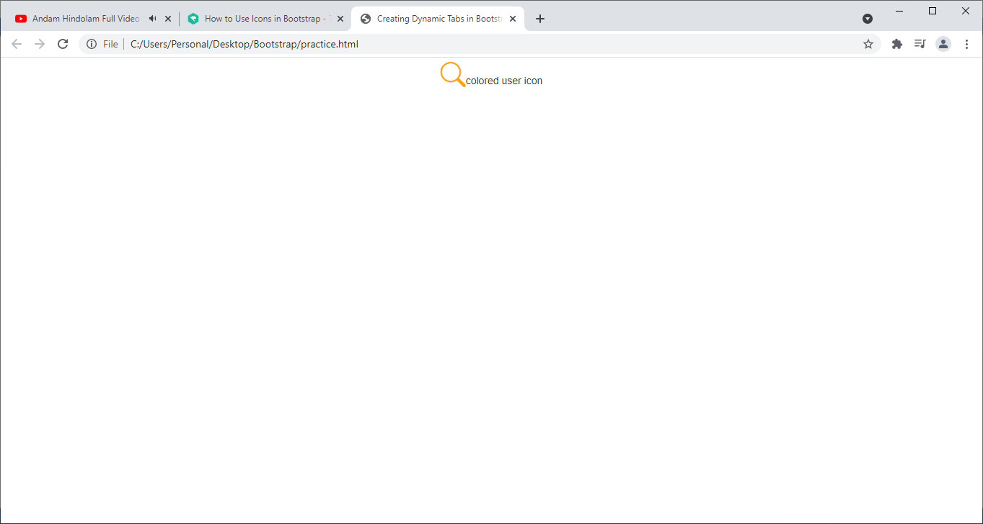

->You can also use external icon libraries in Bootstrap. One of the most popular and highly compatible external icon library for Bootstrap is Font Awesome. It provides over 675 icons which are available in SVG, PNG, as well as in web font format for better usability and scalability.

Step:-1 Put the following line <head> section.

<linkrel="stylesheet"href="https://stackpath.bootstrapcdn.com/font-awesome/4.7.0/css/font-awesome.min.css">

Step:2 use following syntax.

<I class=”fa fa-classname/iconname”></i>

Note:- To know the icon categories and the list of icons go to following web site.

https://fontawesome.com/v4.7/icons/.

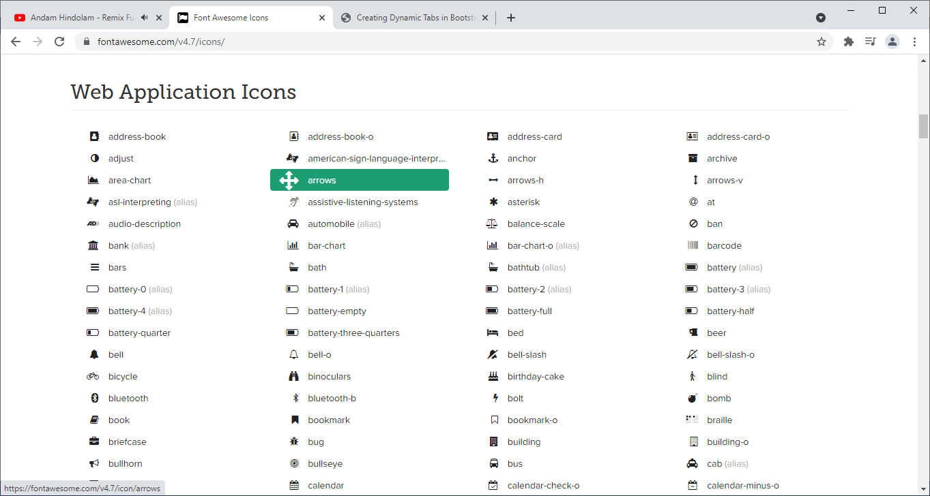

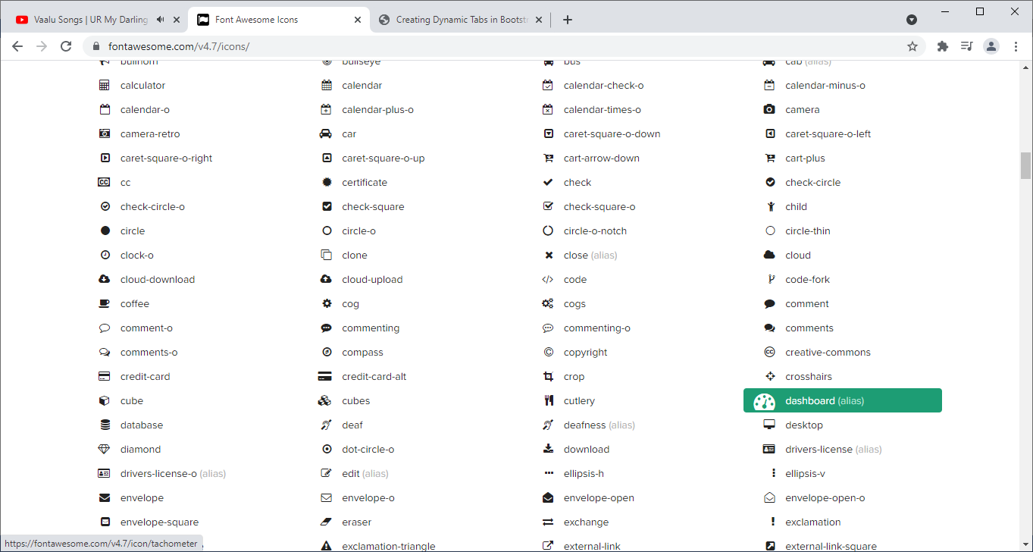

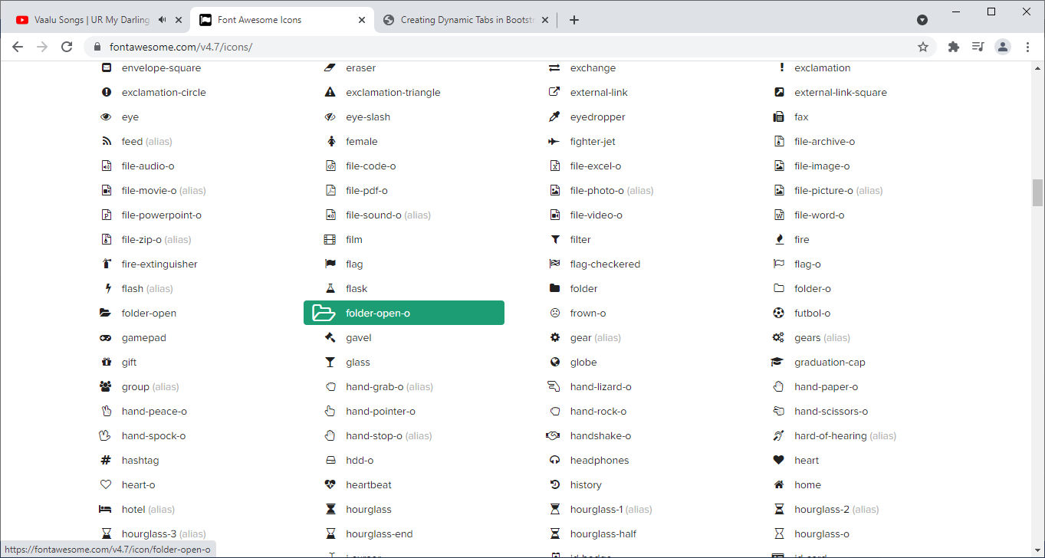

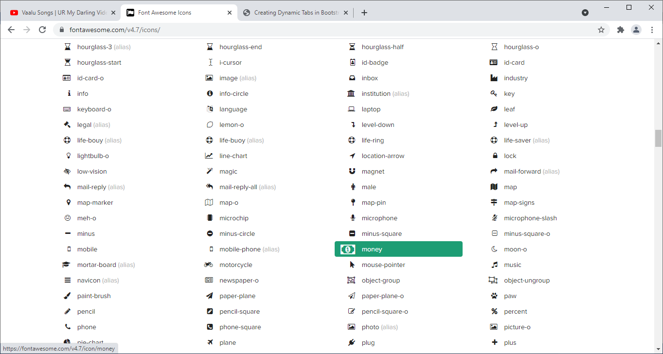

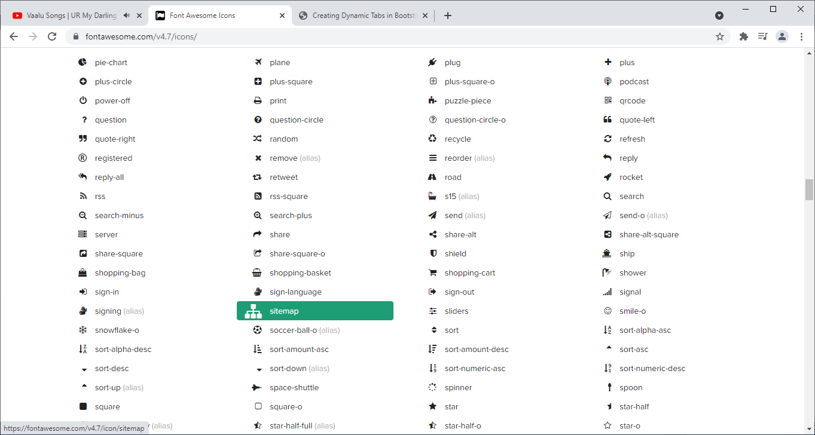

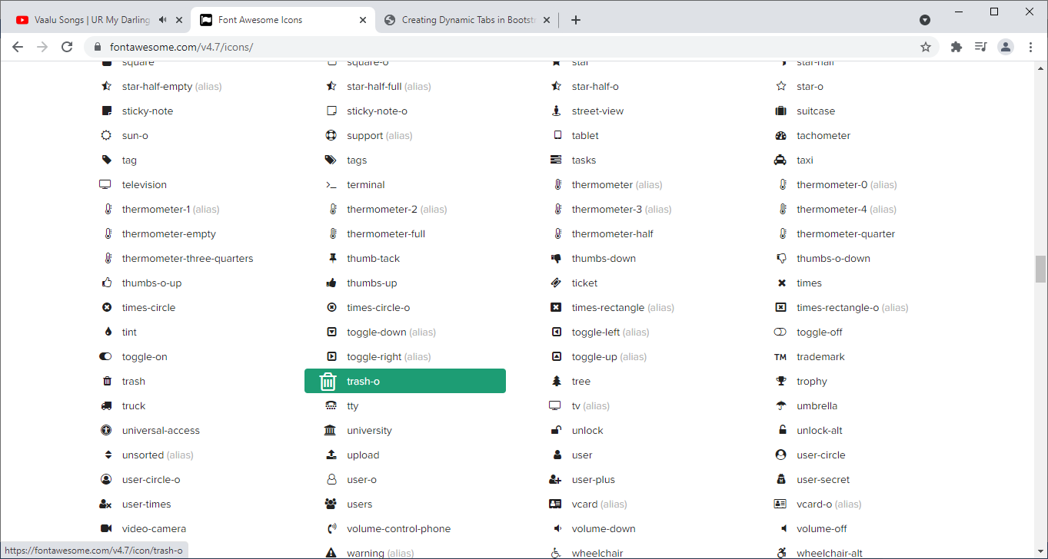

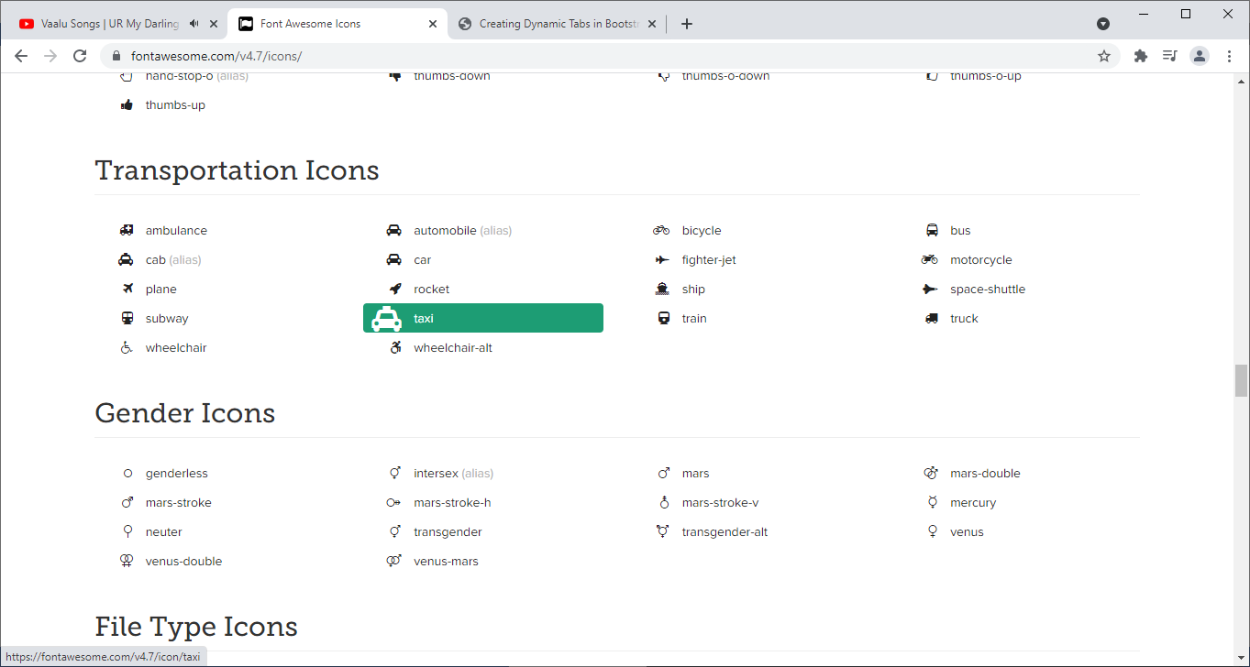

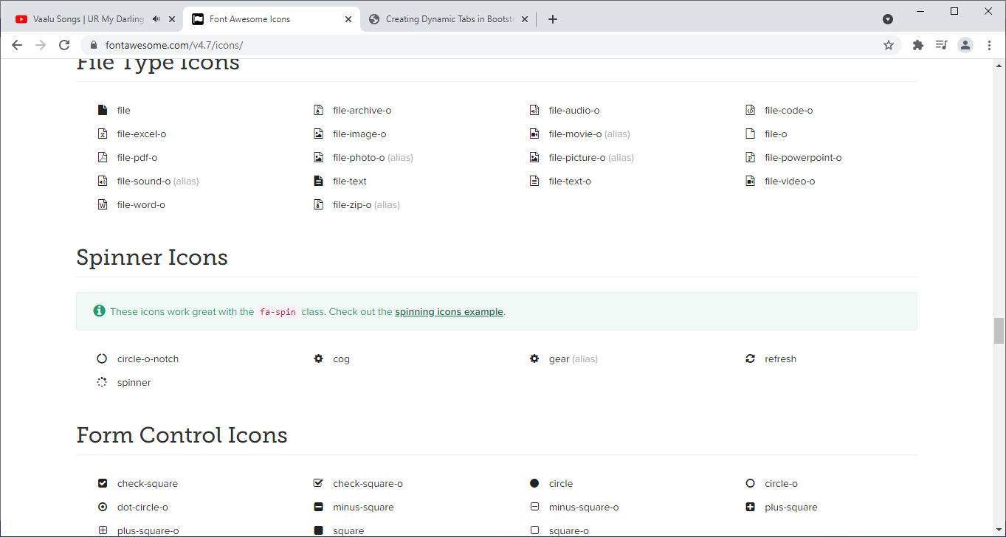

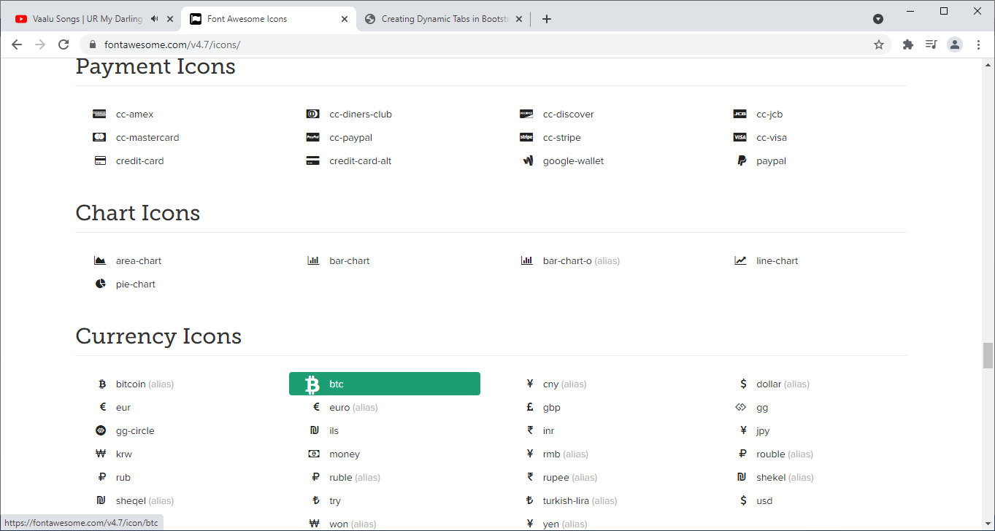

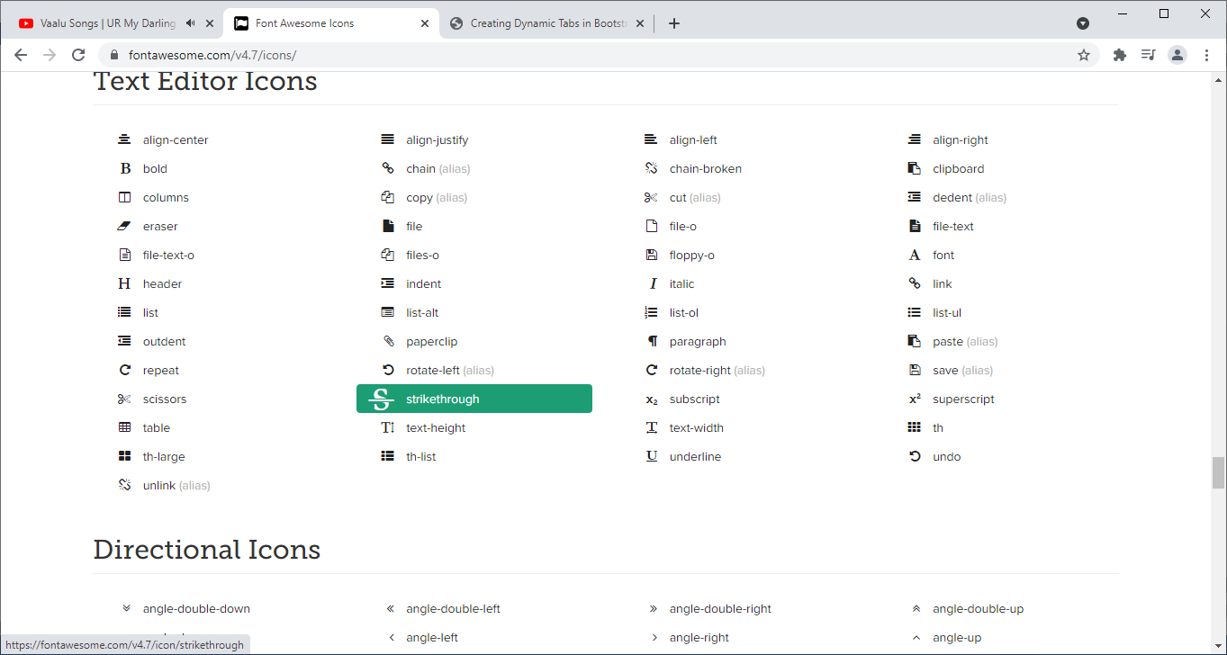

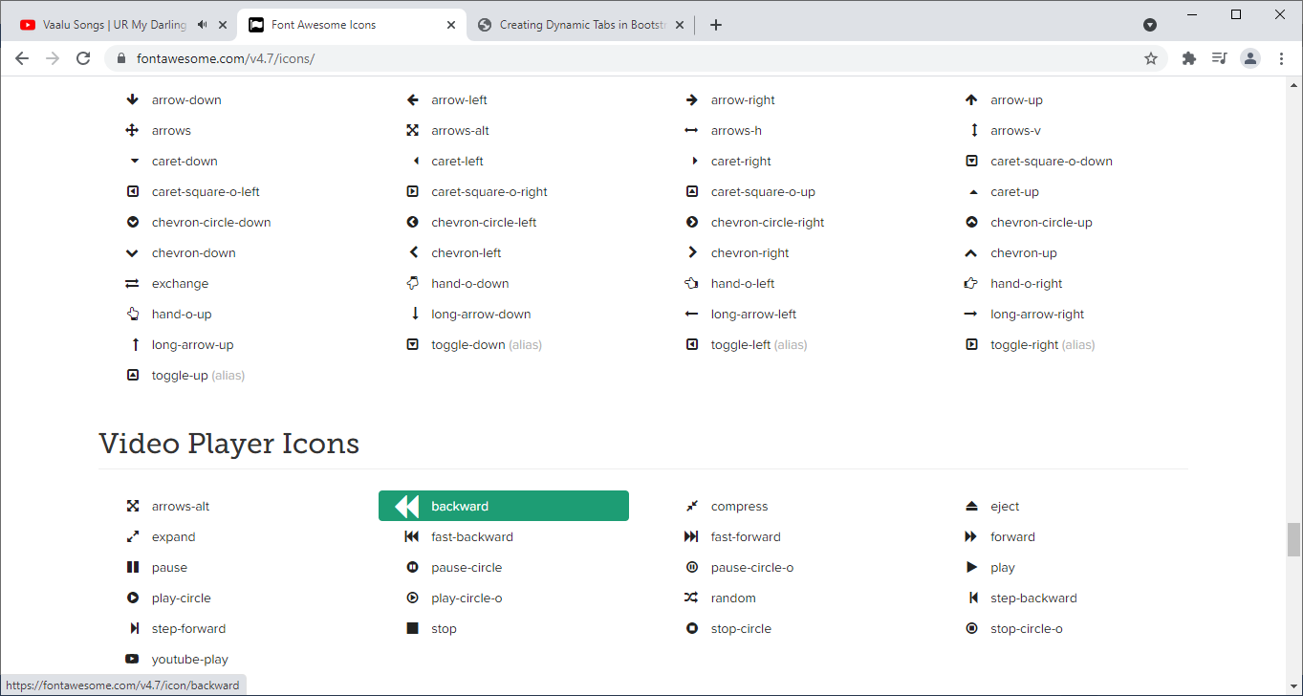

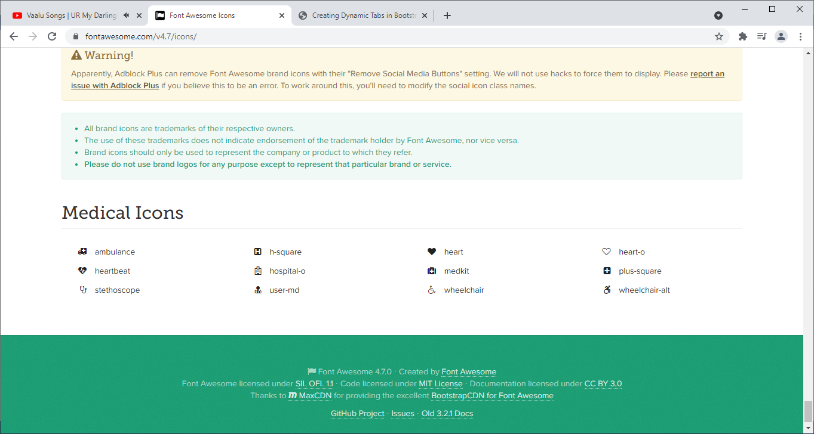

## 30.How to use google fonts in html file?

## A. step:1 place the following line <head> section of .html file.

## <link rel="stylesheet" href="https://fonts.googleapis.com/css?family=Sofia[|....here u can write more family names.]">

## Step:2 write the following statement in css file.

## Font-family:familyname;

## Example:-

## -------------

## With out using the google font.

## 

## With google font.

## <style>

## h2{font-family: Raleway;}

## </style>

## </head>

## <body>

## <h2>Sukumar</h2>

## </body>

## Output:

## 

31) Difference between Bootstrap3 and Bootstrap4 .

A)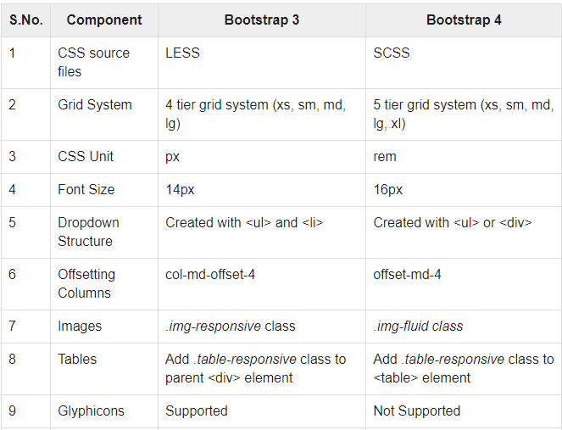

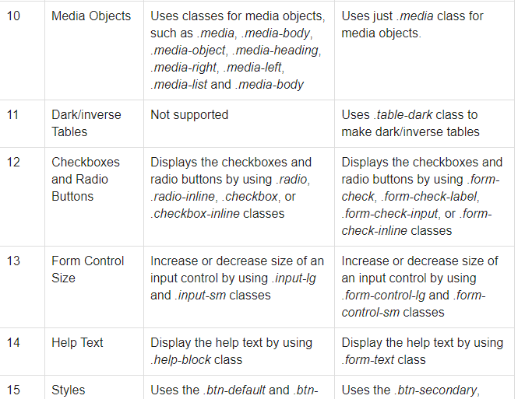

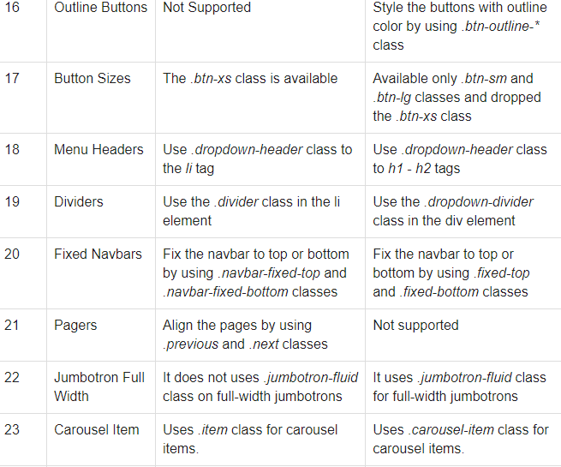

32)color:-

Websites with respect to color:-

a)[www.colors.com](http://www.colors.com) ---🡪 we can see the several color pallates. Where to generate color palate press ‘space’.

b)<https://www.rapidtables.com/web/color/RGB_Color.html> ---> in this website, we see color names and their Hex code and decimal code.

c)<https://www.color-blindness.com/color-name-hue/---->> From this website,we can know the color name using hex code and decimal code.